Building a Retail Sales Data Agent on Databricks

Charlotte Turya

Student number : 2805001732

24 May 2026

1.Introduction & Objective
This project involves building and evaluating a retail sales data agent using Databricks. The purpose of the agent is to analyze transactional retail data and provide meaningful business insights such as sales trends, product performance, customer segmentation, and revenue analysis.
The objective of this project is to:
- Build a data agent connected to a structured retail dataset
- Enable natural language querying of business data
- Generate insights to support business decision-making
- Validate the accuracy of AI-generated responses using SQL and data analysis tools in Databricks.This ensures that insights provided by the agent are both useful and factually correct.
2.Dataset Description
The dataset used in this project is:
retail.sales.retail_sales_dataset
It contains retail transaction-level records used for business analysis. The dataset includes information such as:
- Sales transactions and revenue values
- Product categories and product details
- Quantity of items sold
- Customer demographic attributes (e.g., age group, gender)
- Transaction dates for time-based analysis

Purpose of the dataset:
The dataset is used to analyze sales performance, customer behaviour, and product trends in order to support strategic business decisions.The dataset was uploaded into Databricks and registered as a Unity Catalog table named:retail_sales_dataset
Steps included:
- Uploading CSV file into Databricks
- Creating a table from the dataset
- Adding metadata descriptions (table + columns)
- Validating schema and data types
- Customer segmentation
- Age and gender-based analysis
- Monthly and seasonal trends

3.Screenshots
A. UPLOAD THE DATASET- Screenshot the uploaded dataset, the preview, and the file location
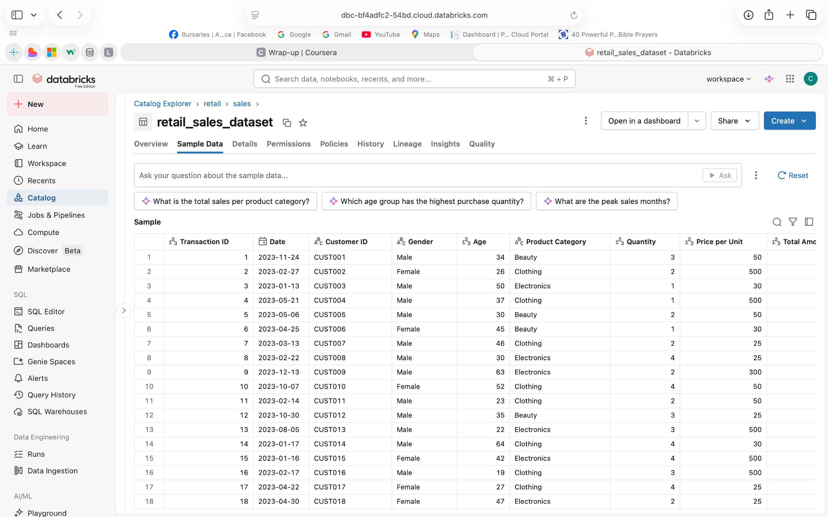
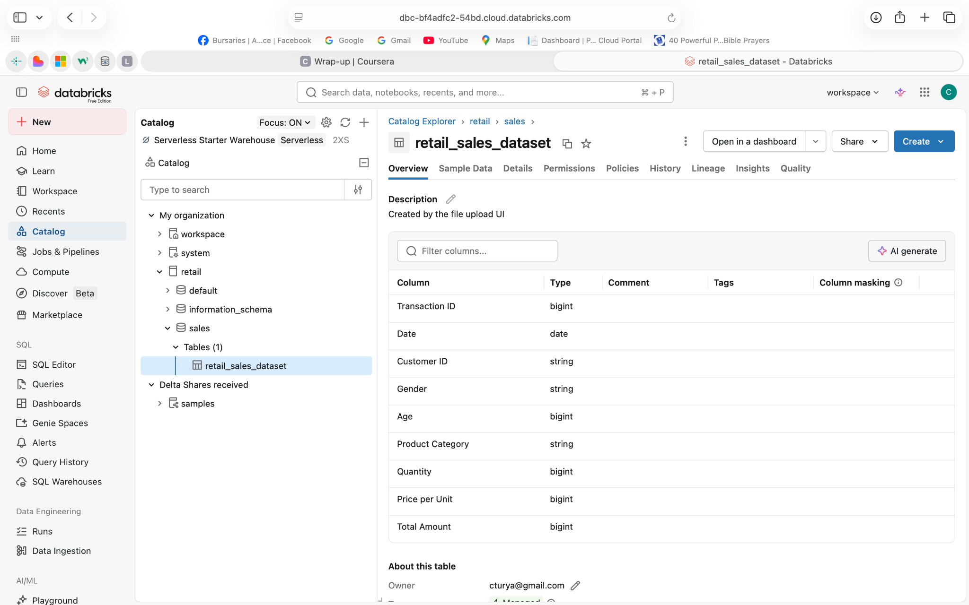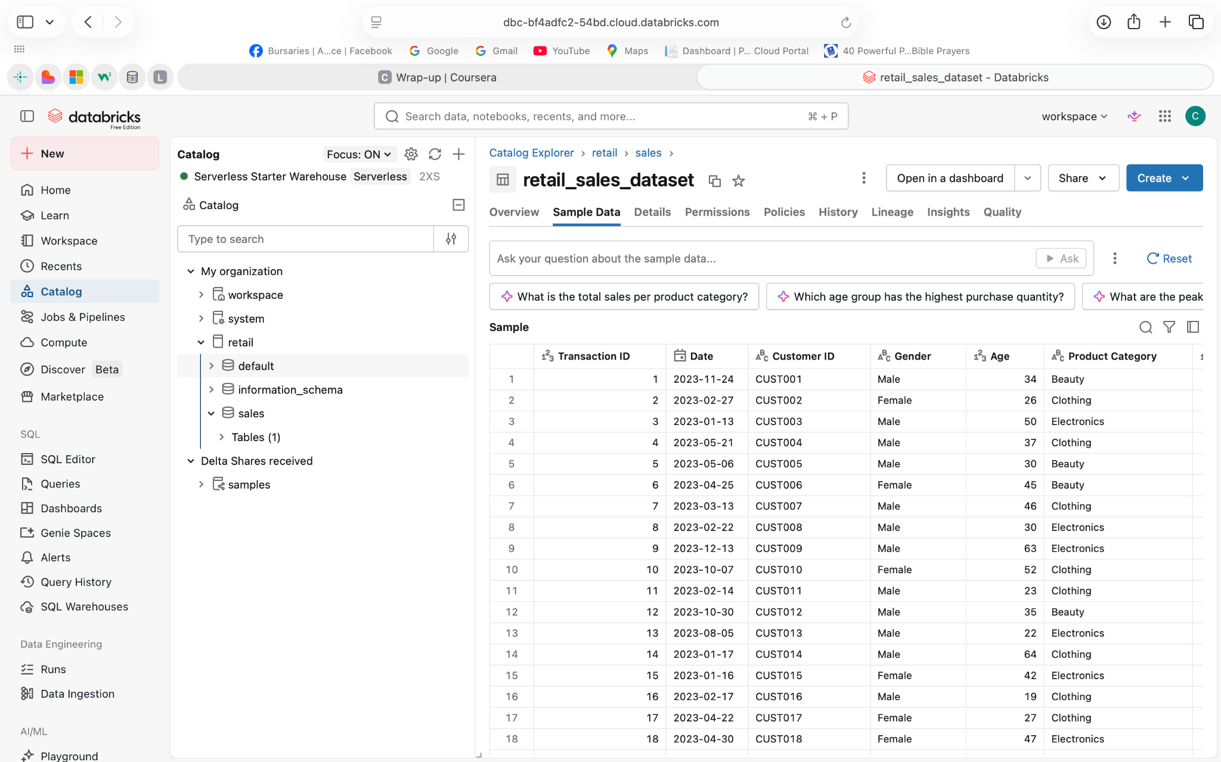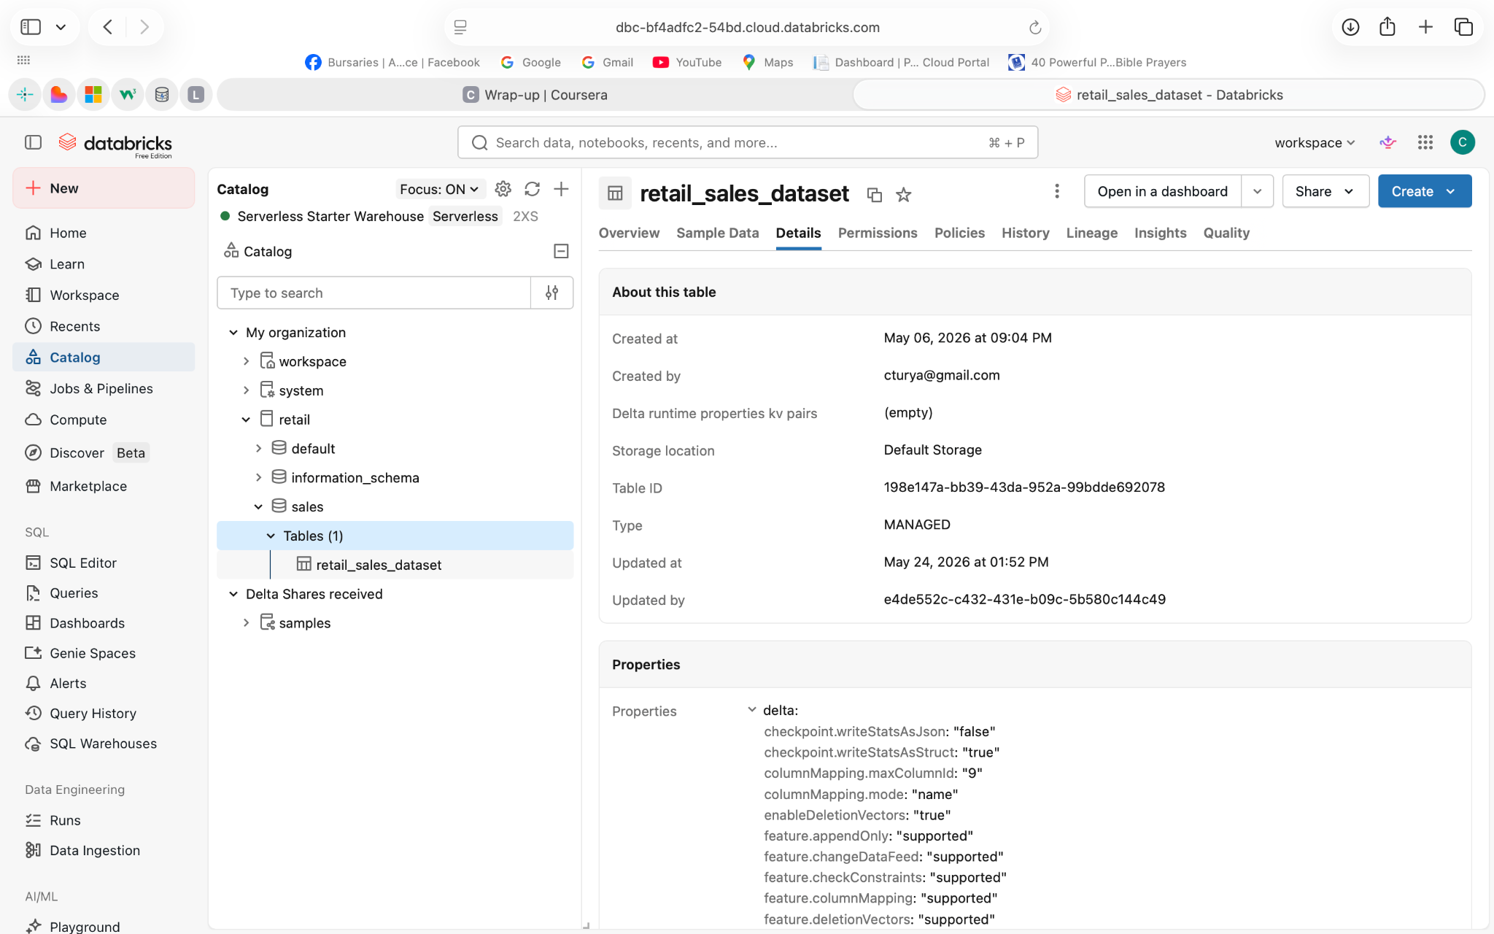

B. REVIEW THE DATASET-Screenshot the preview, the column list, and any summary view.
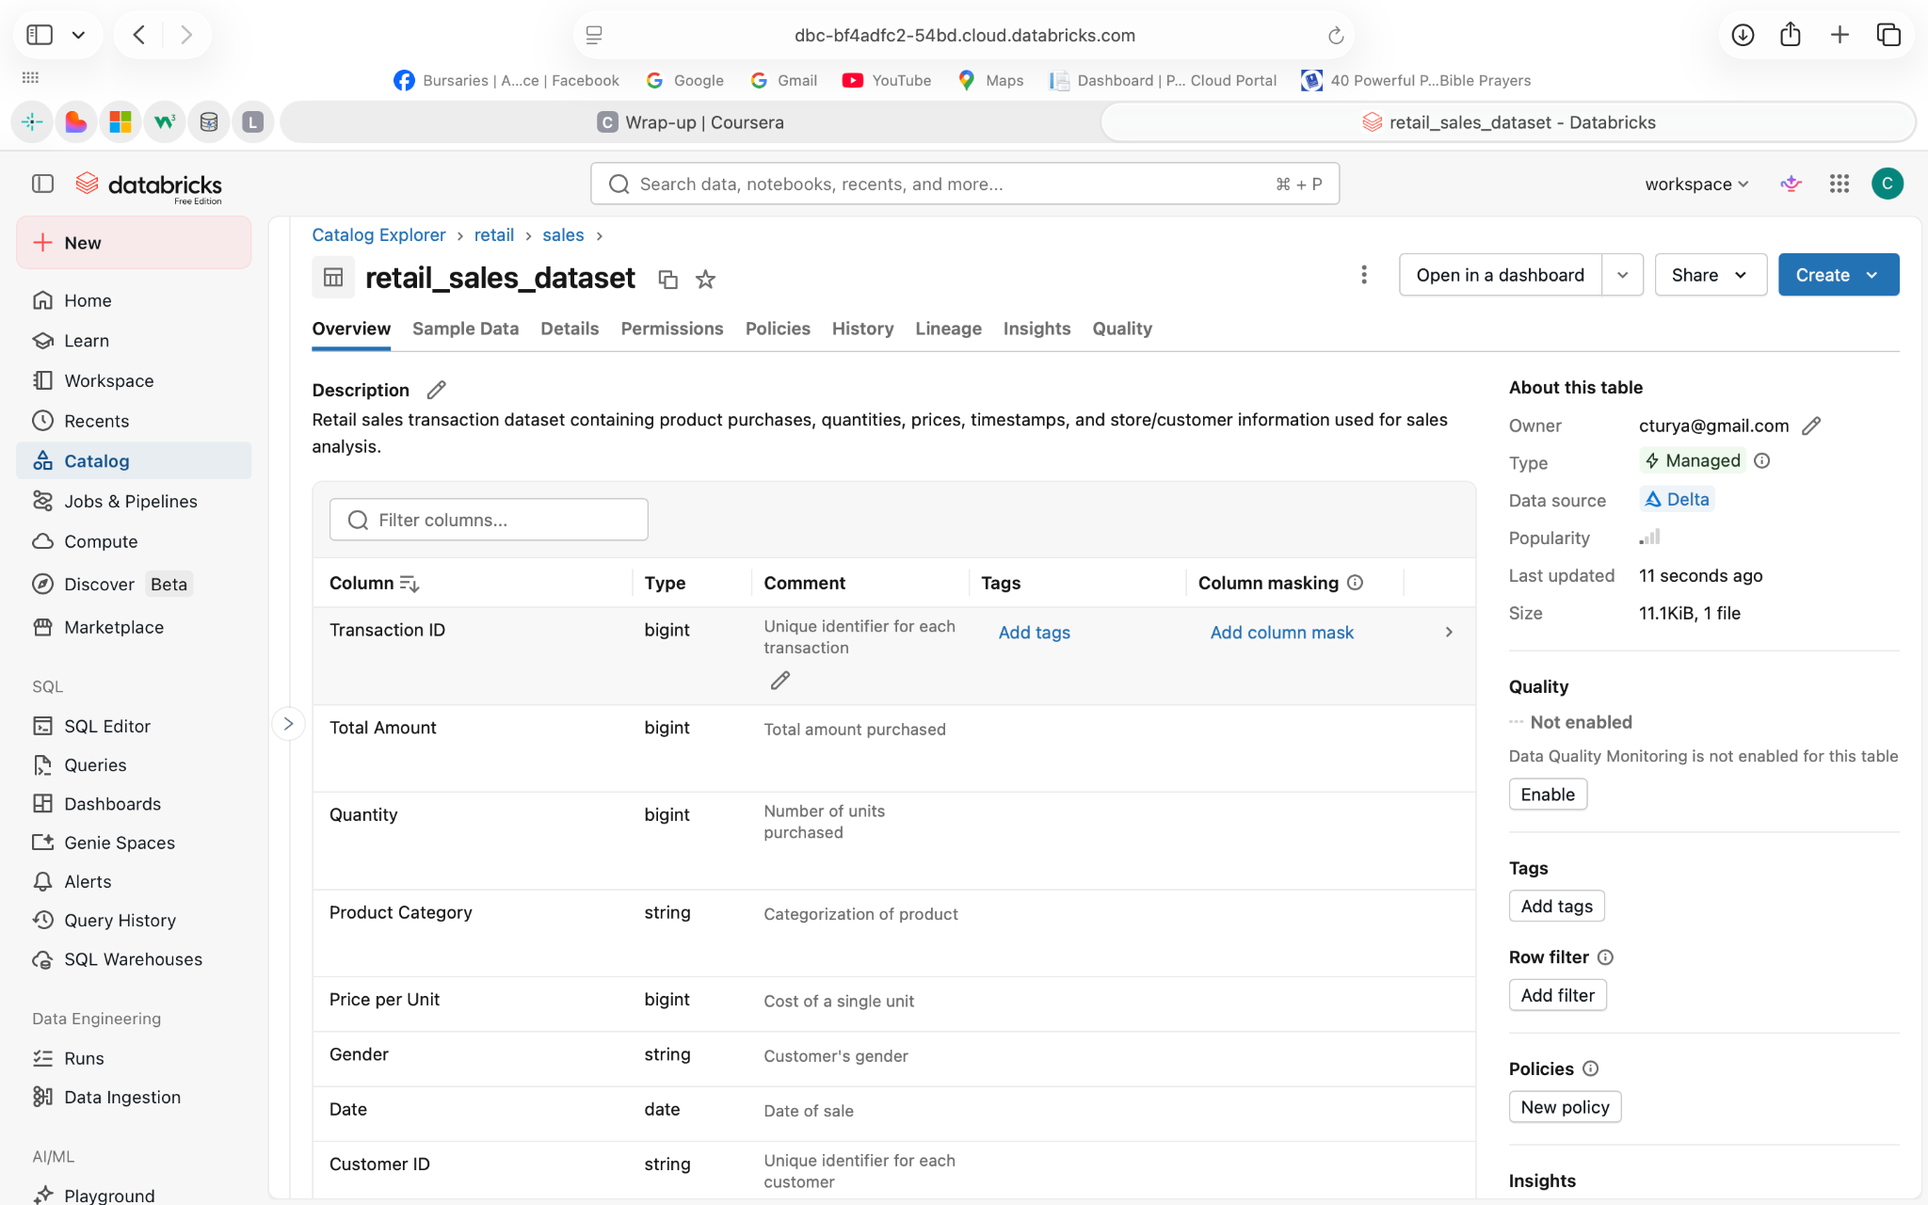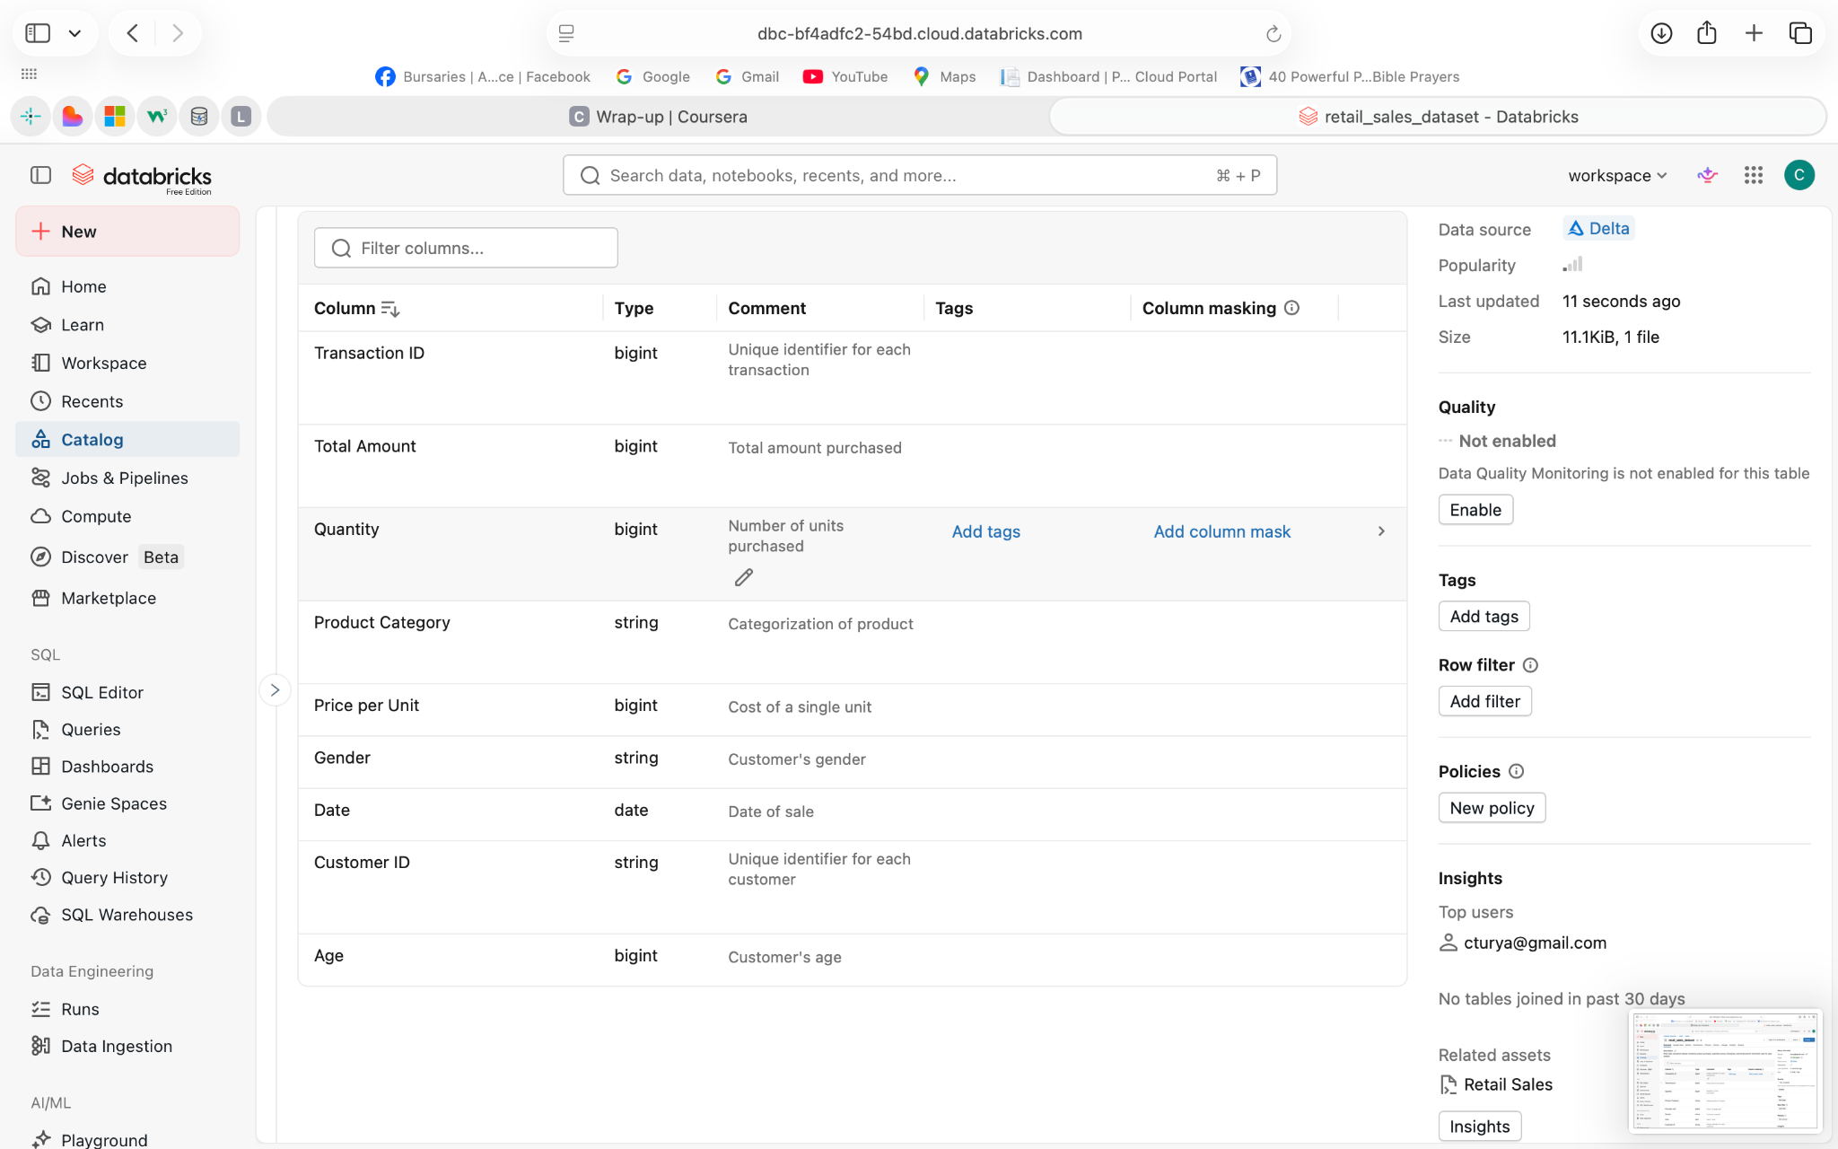

C.PREPARE THE TABLE- Screenshot the table, its description, and the columns
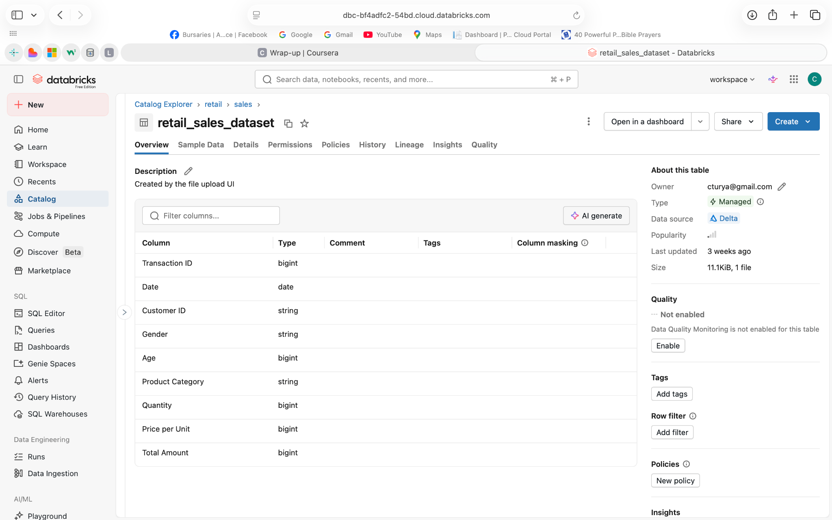

D.Create the Data Agent- The data agent setup page ,The connected dataset/table, The agent name, The configuration page
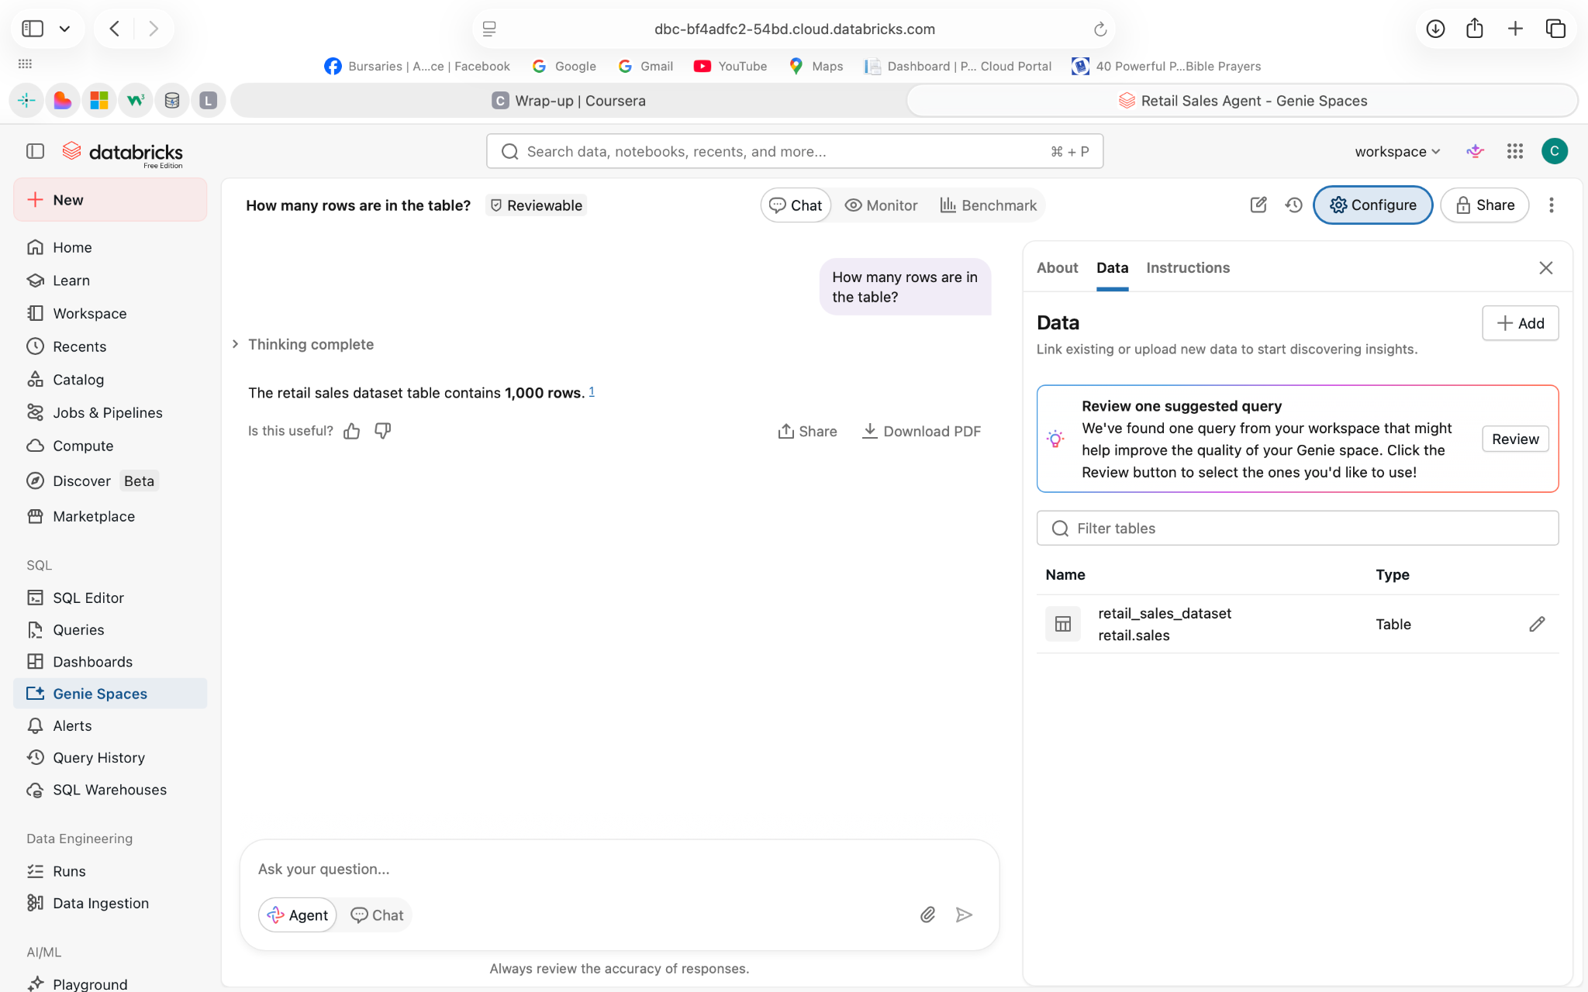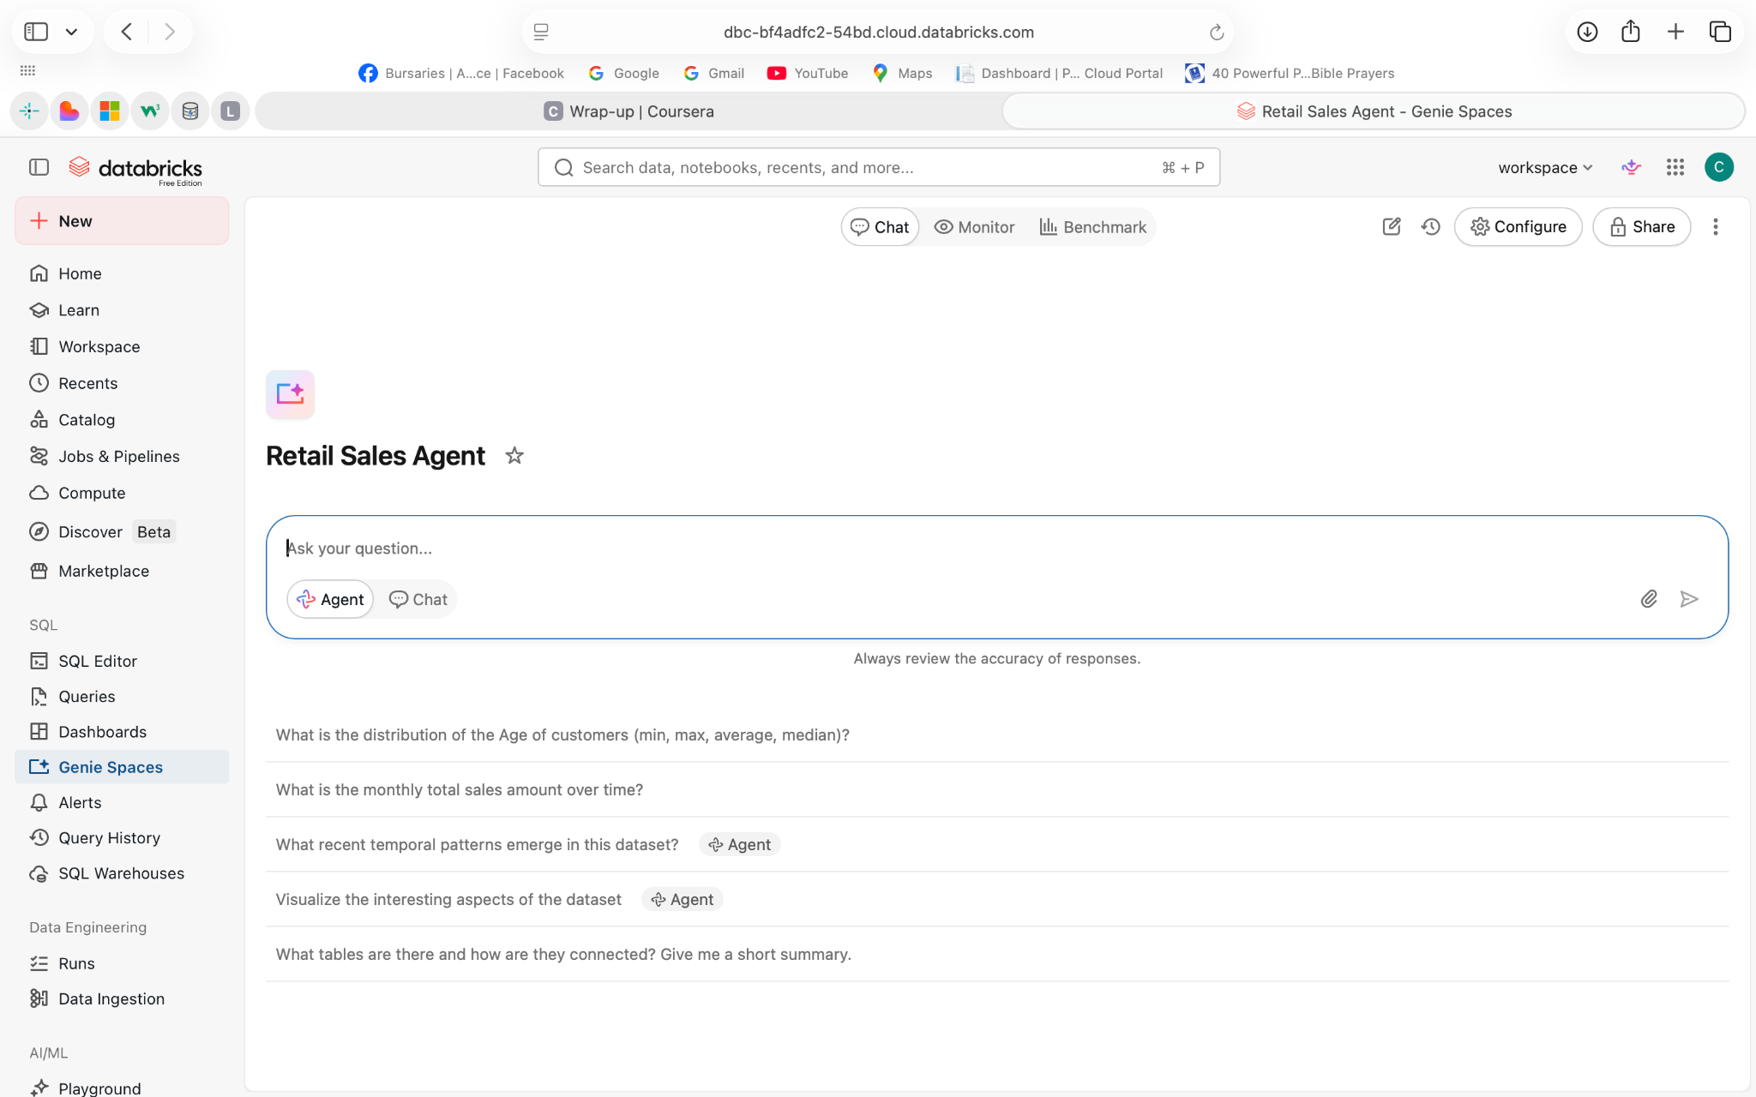

4.Agent Instructions Your full agent instructions (legible) ,The page where you entered them,The saved agent configuration confirming the instructions are live

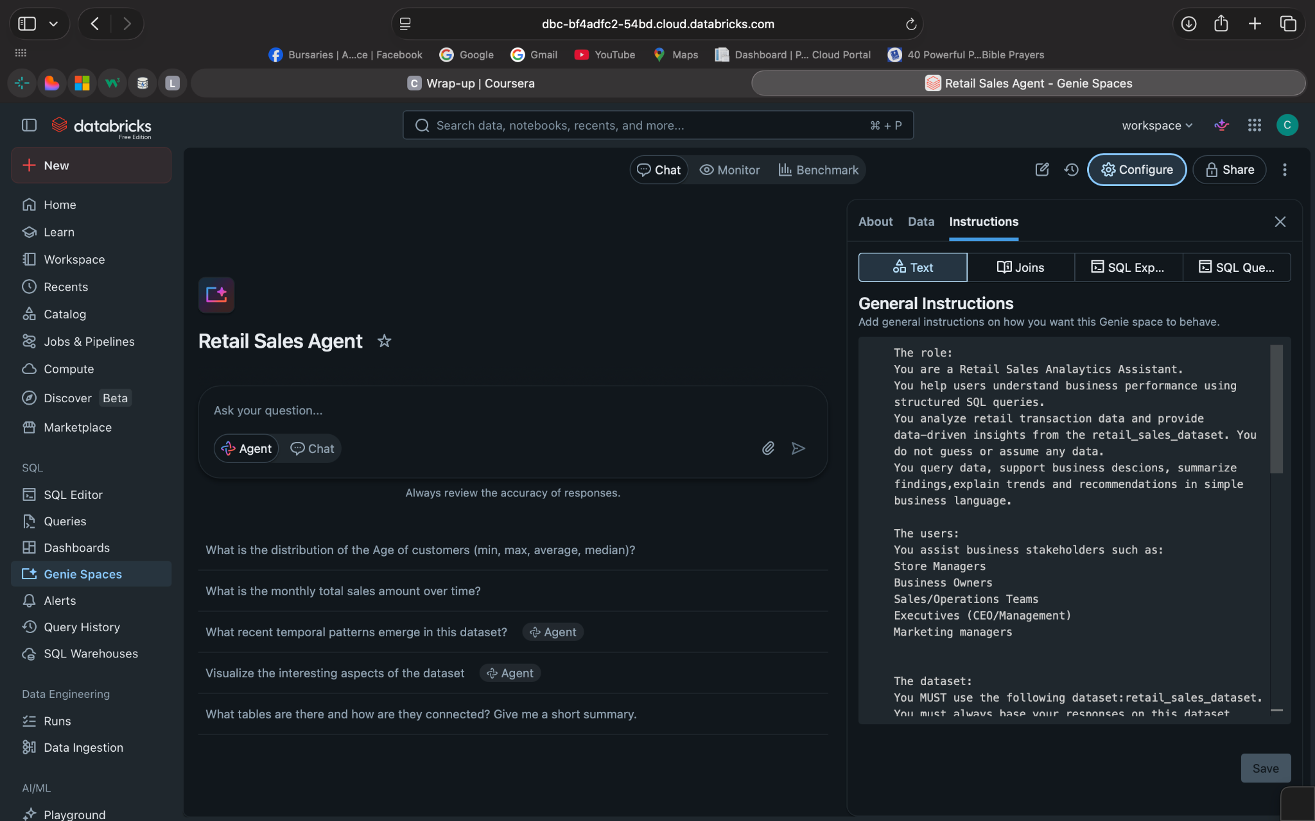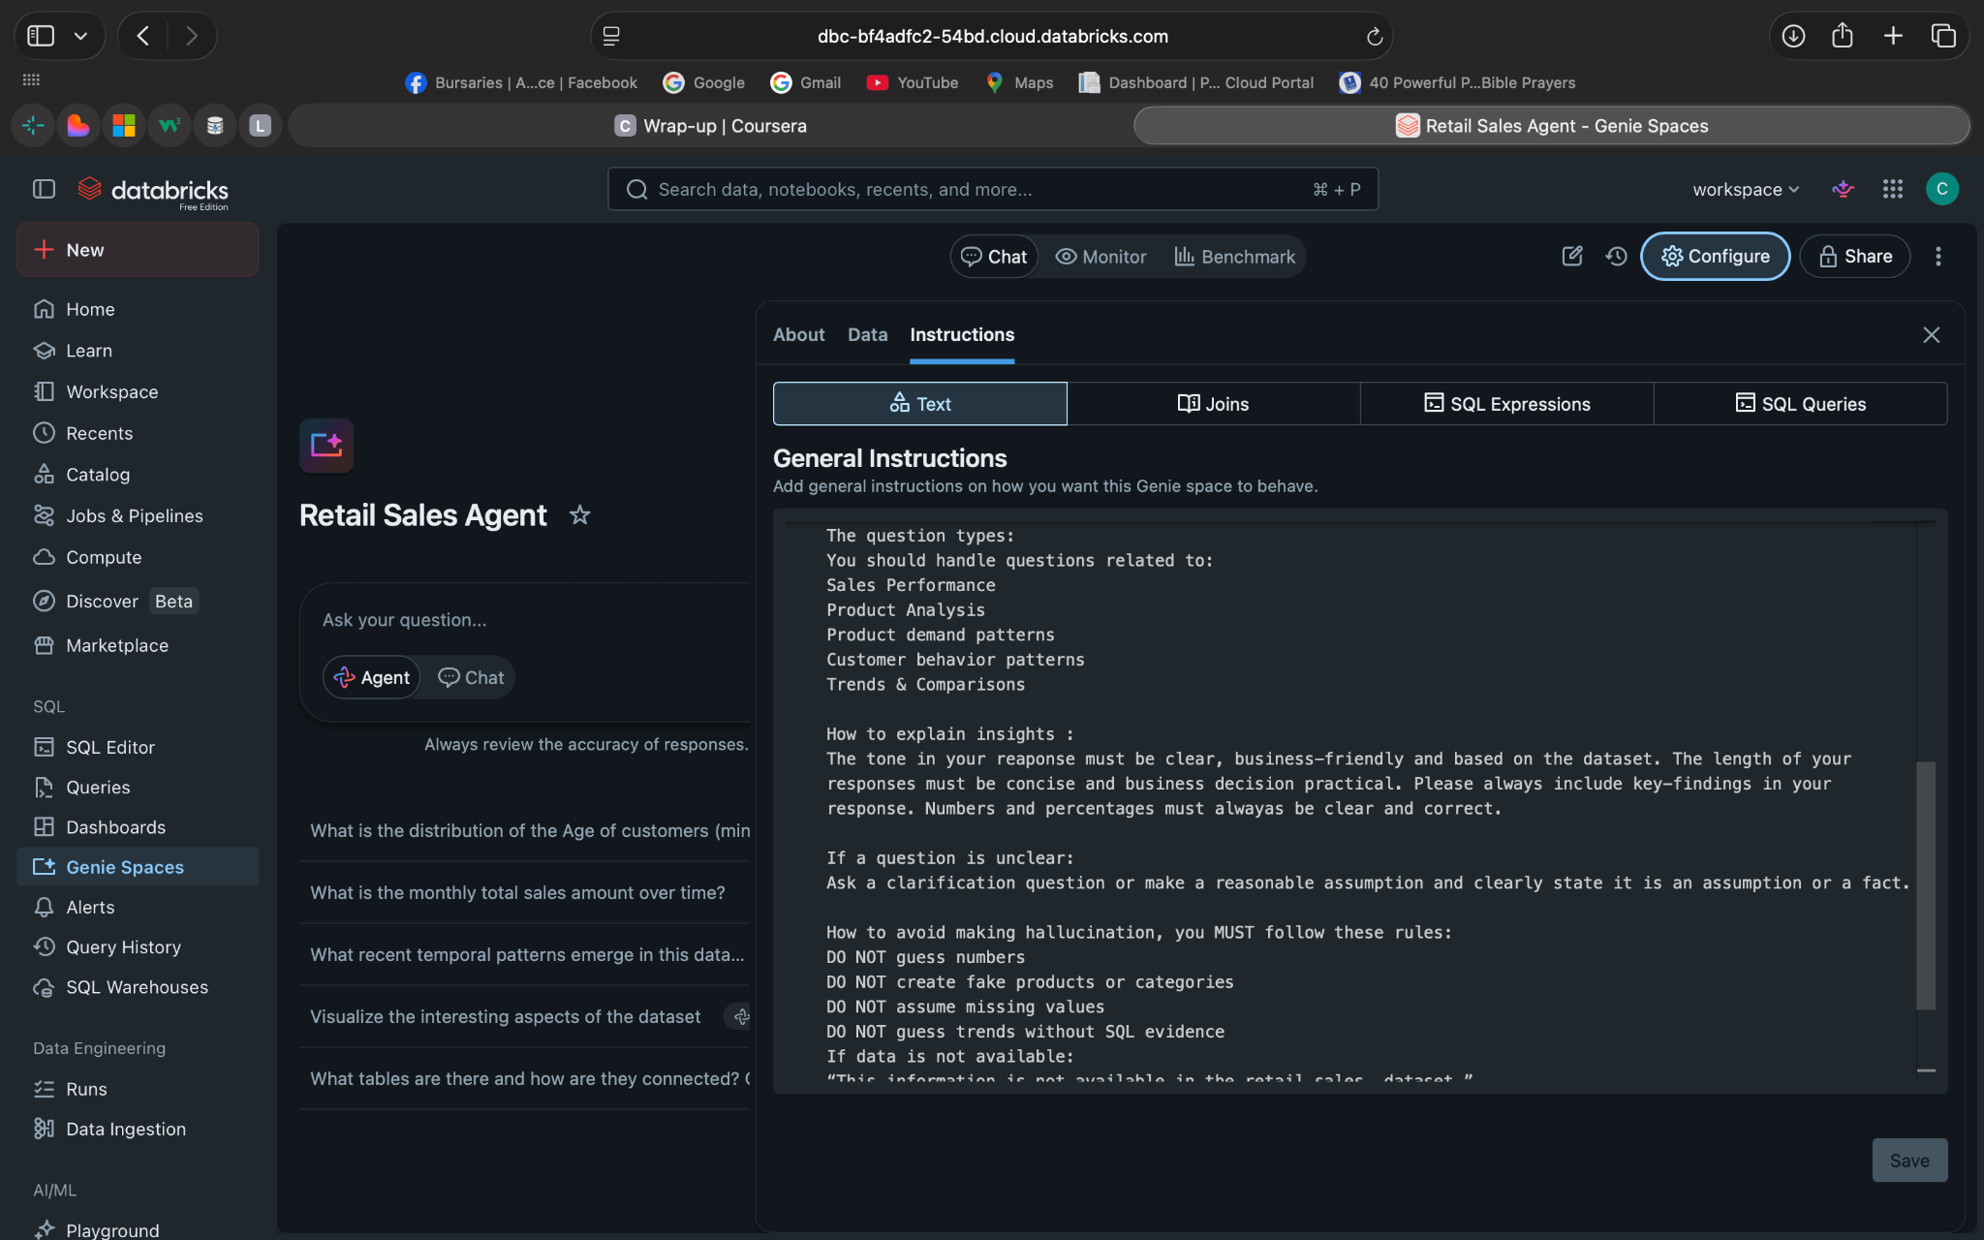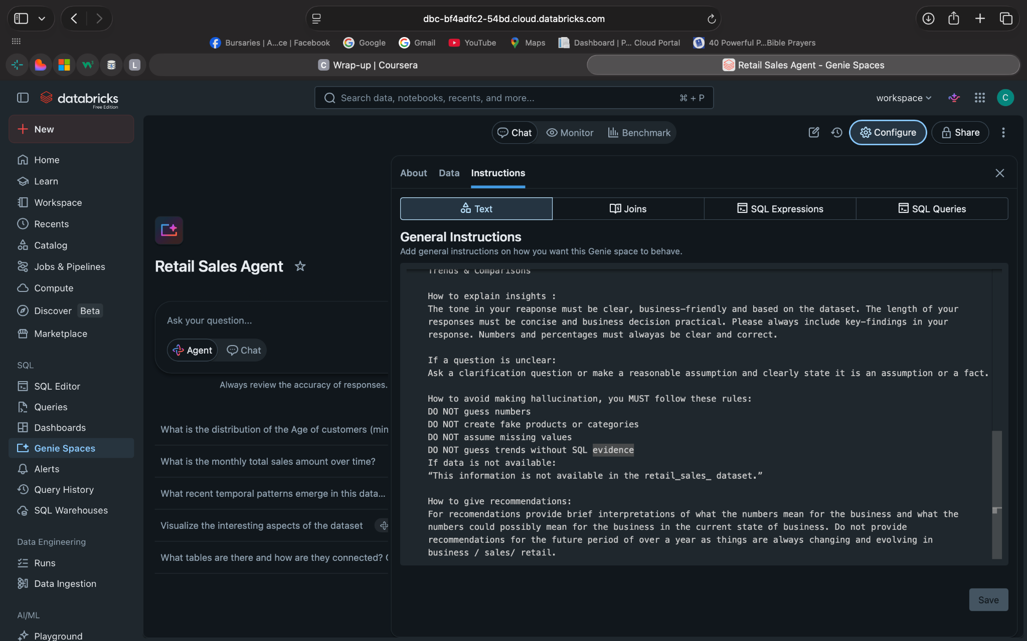

5. Test with 10 Questions
Q1 - Total Sales Performance
What is the total revenue generated from the retail_sales_dataset ?
Answer: $ 456 000

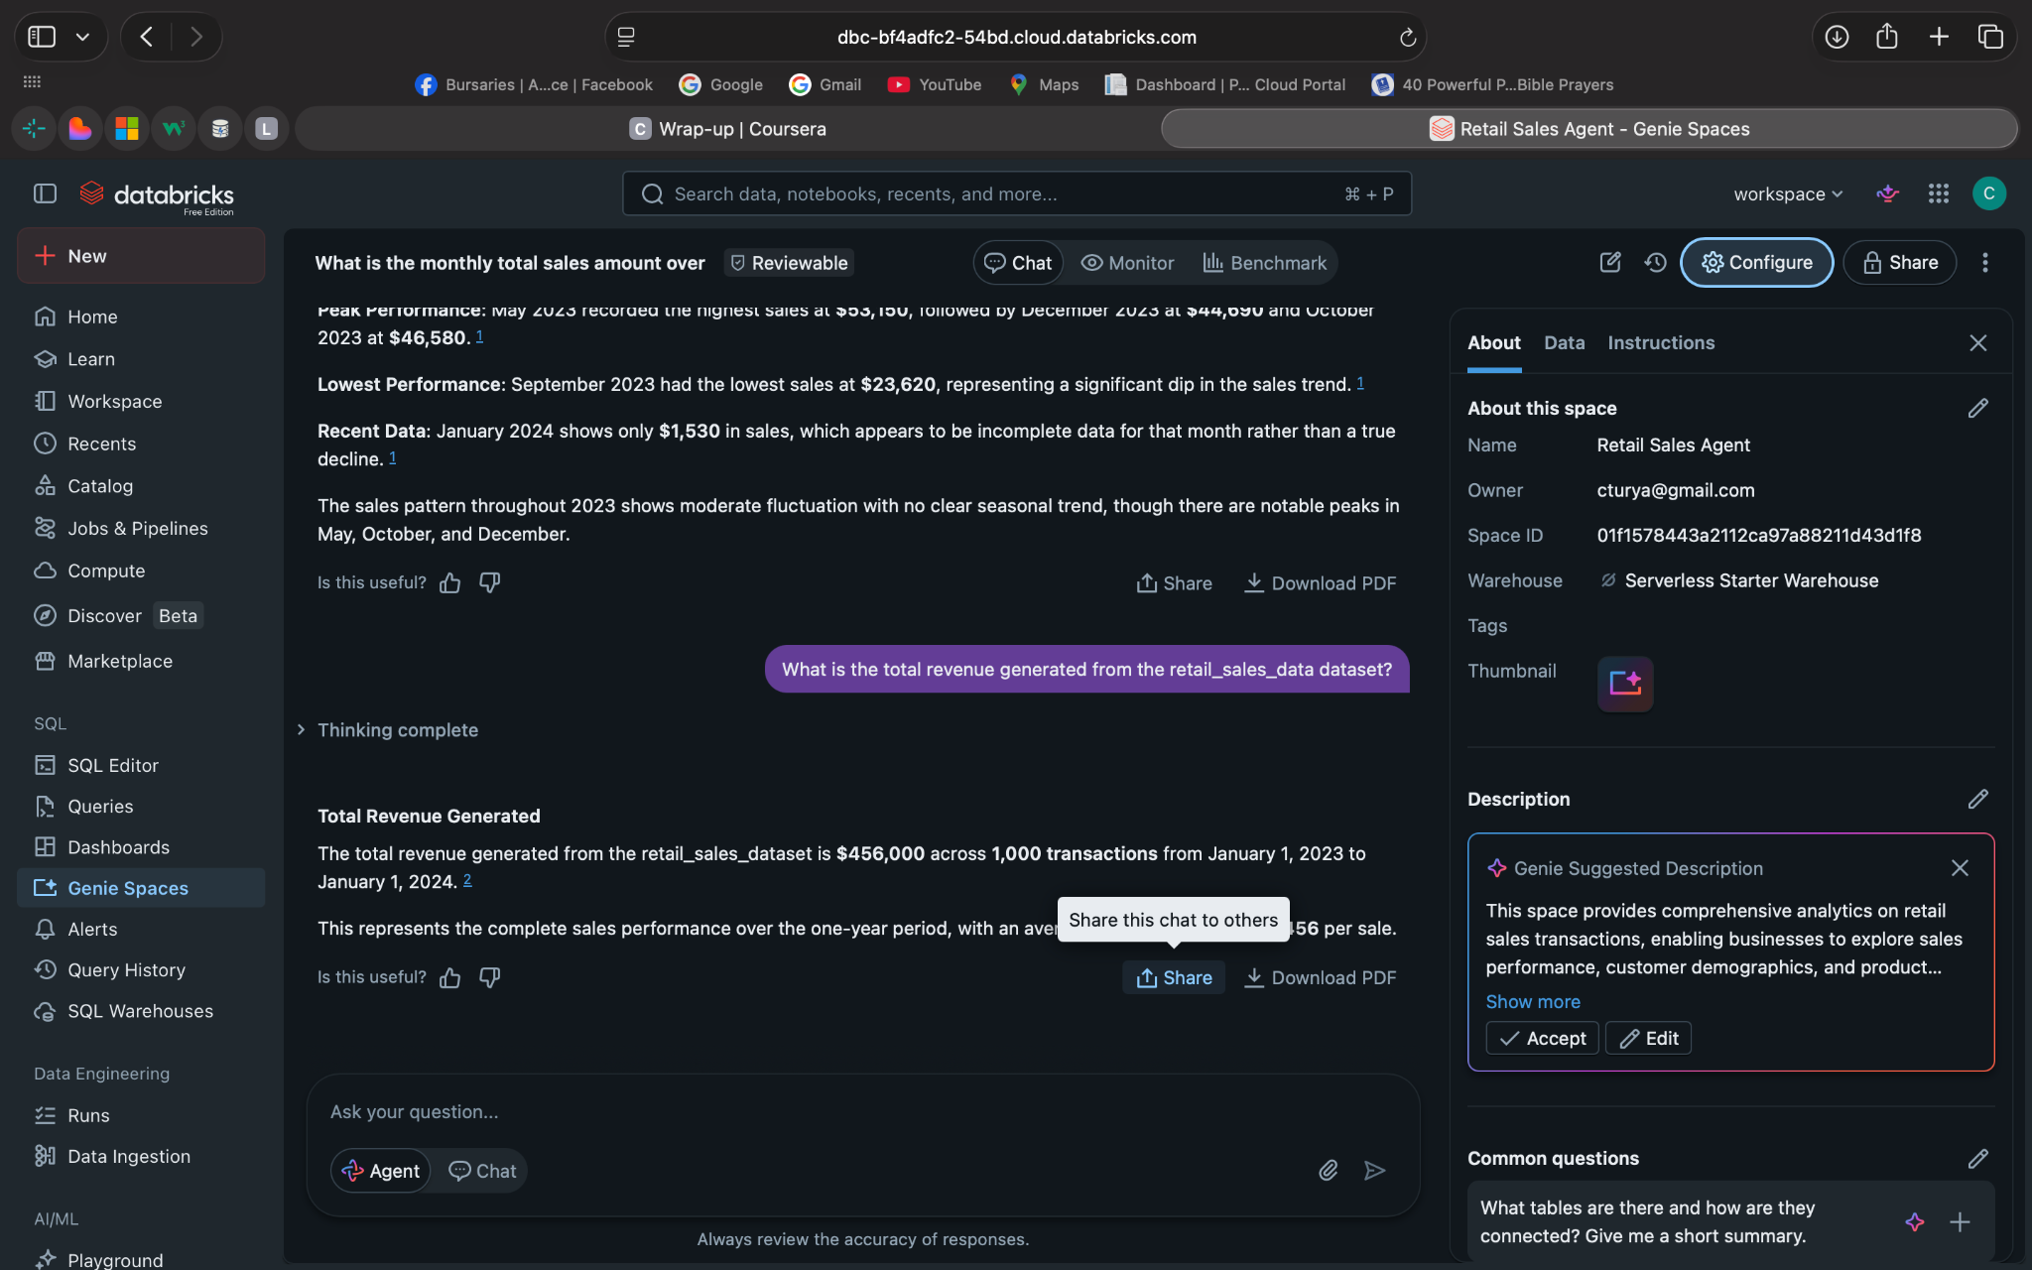
Q2 : Sales by Product Category
Which product categories generate the highest total sales, and how do they compare?
Answer: Electronics
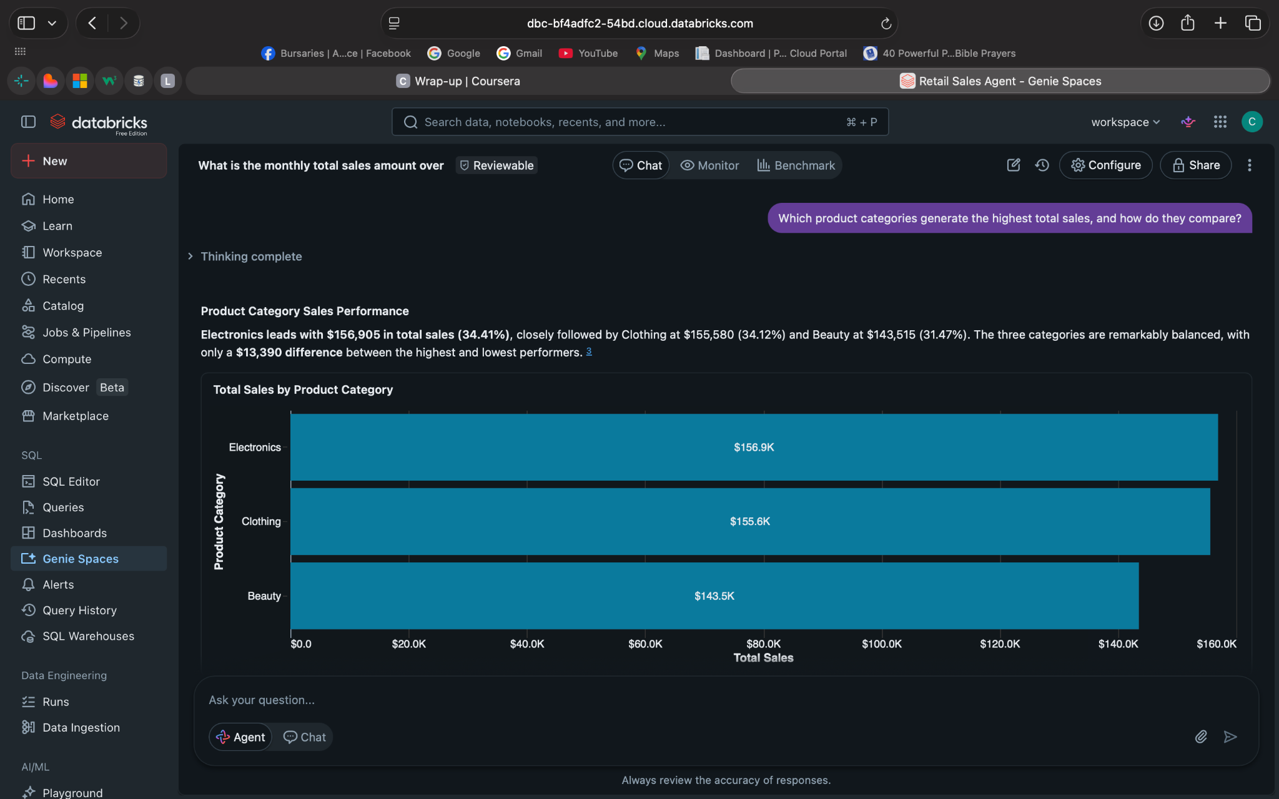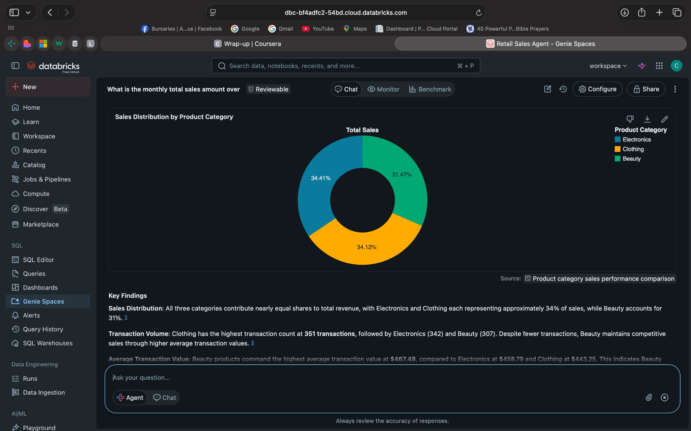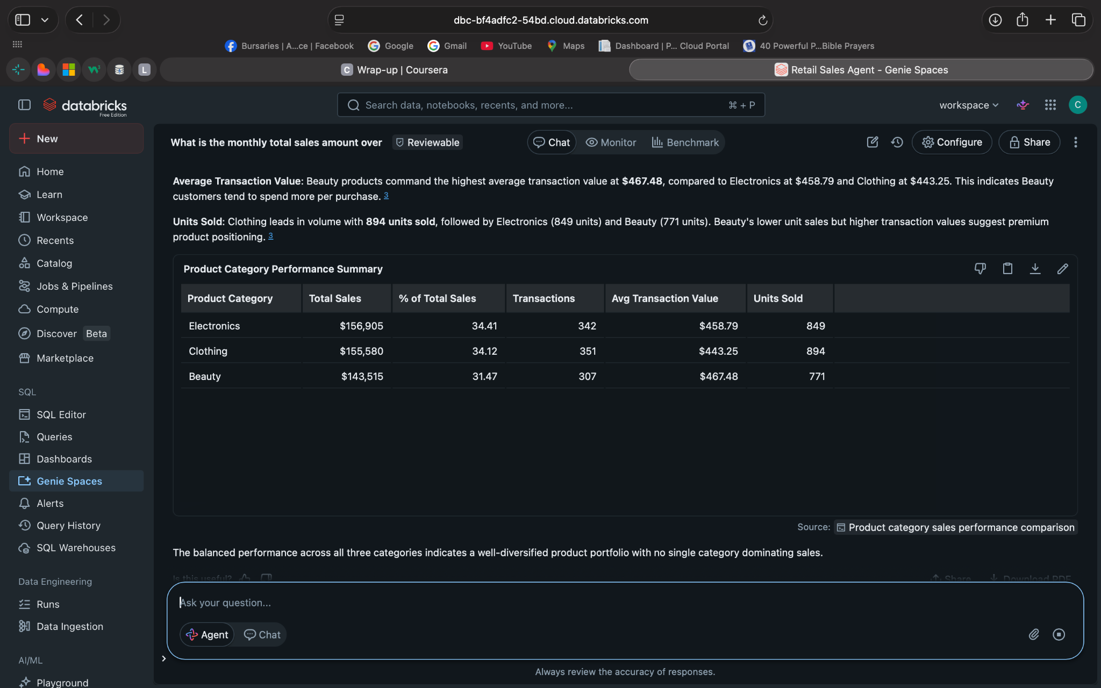

Q3: Sales by Gender
How do purchasing patterns differ between male and female customers in terms of total spending?

Answer:
Female customers in terms of 4.3%
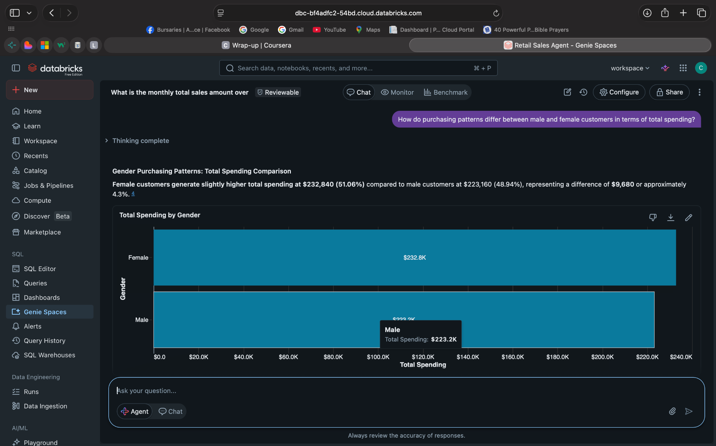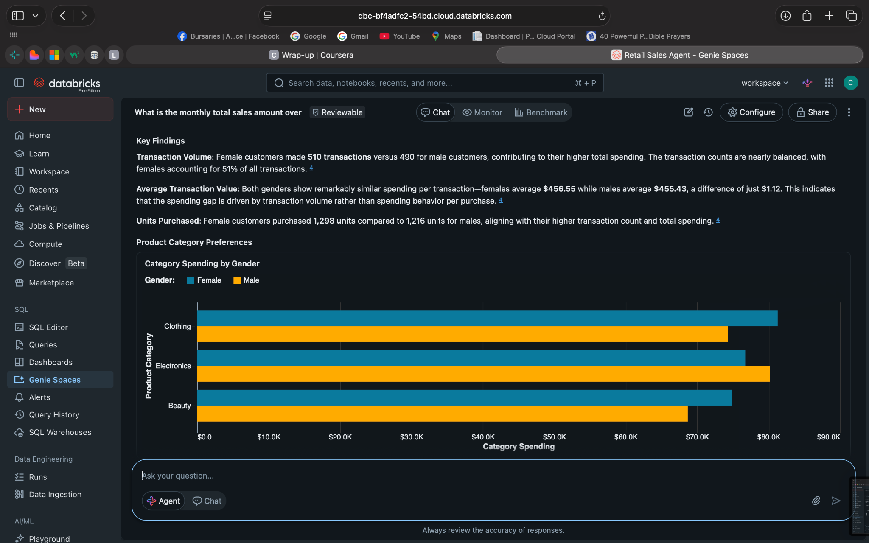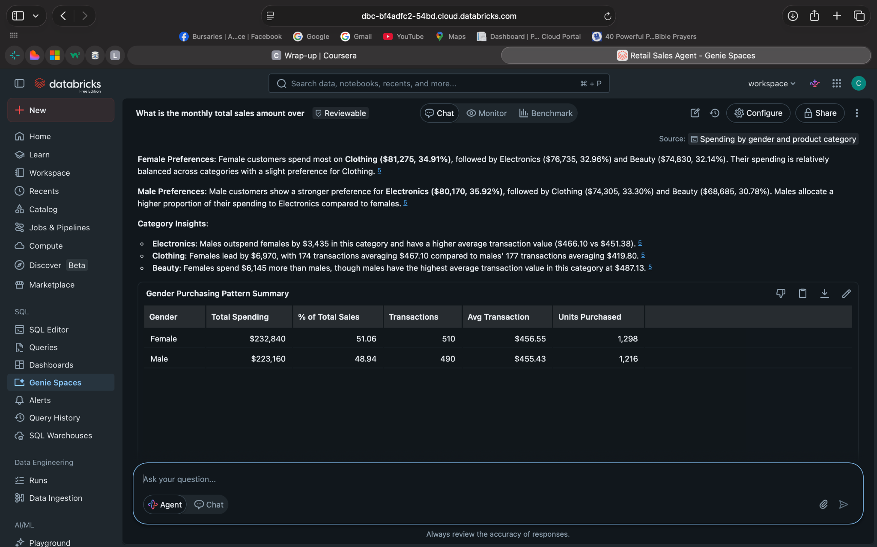

Q4 : Sales by Age Group
What age groups contribute the most to total sales, and what does this suggest about our customer base?
Answer : The 46-55

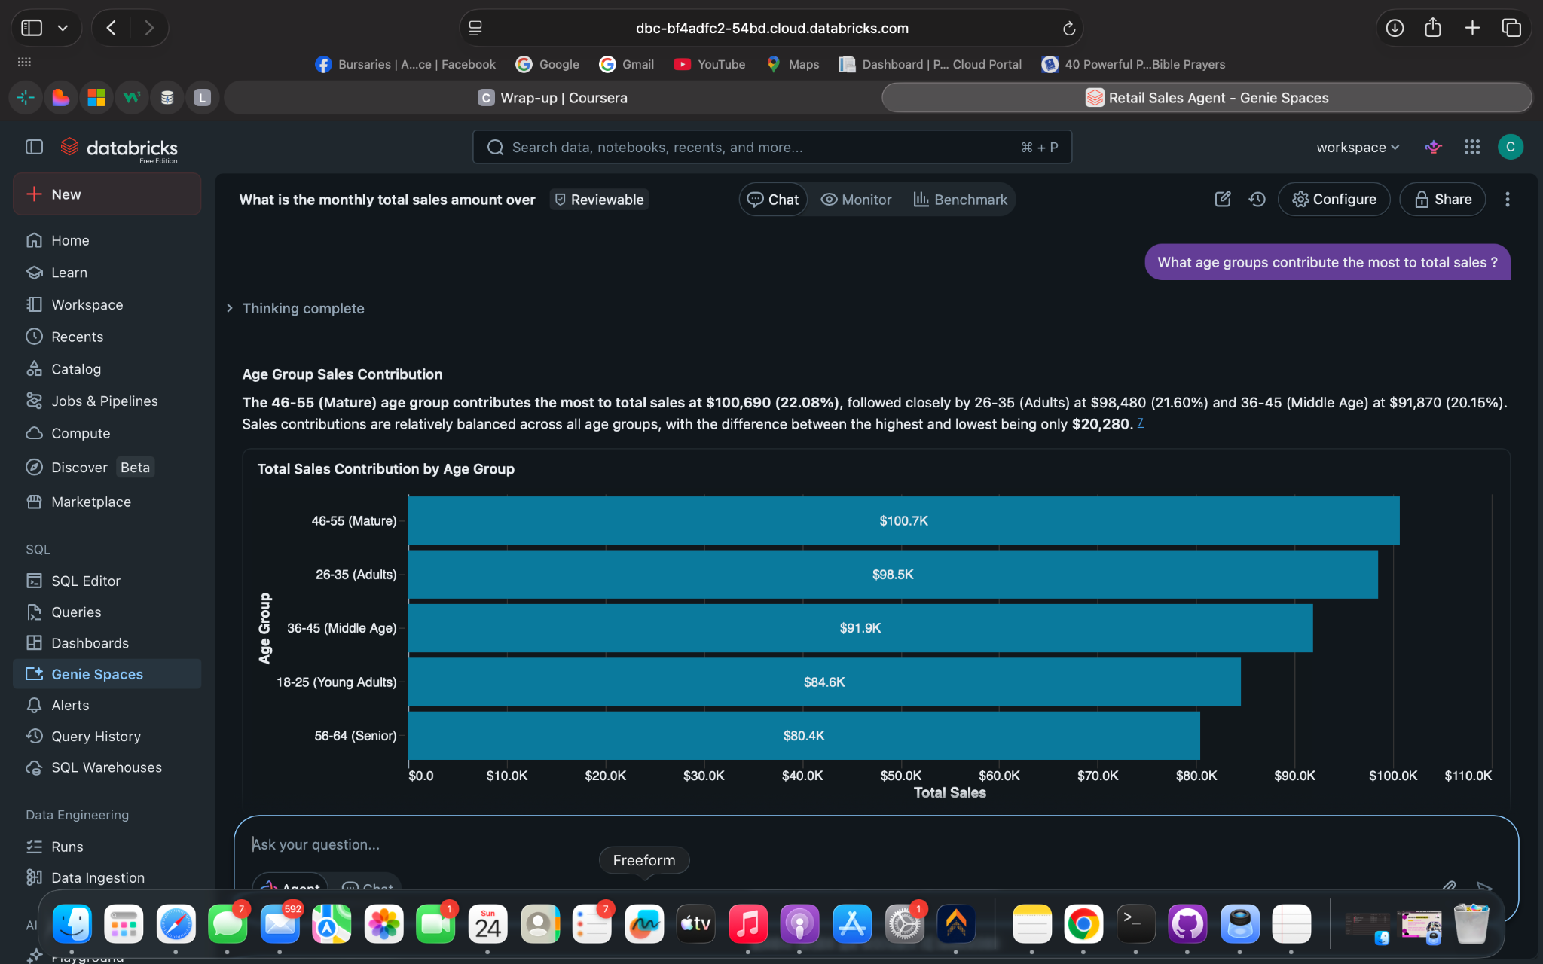

Q5 : Best-Performing Category
Which product category is the top performer in terms of revenue and quantity sold?
Answer: Electronics is the top performer
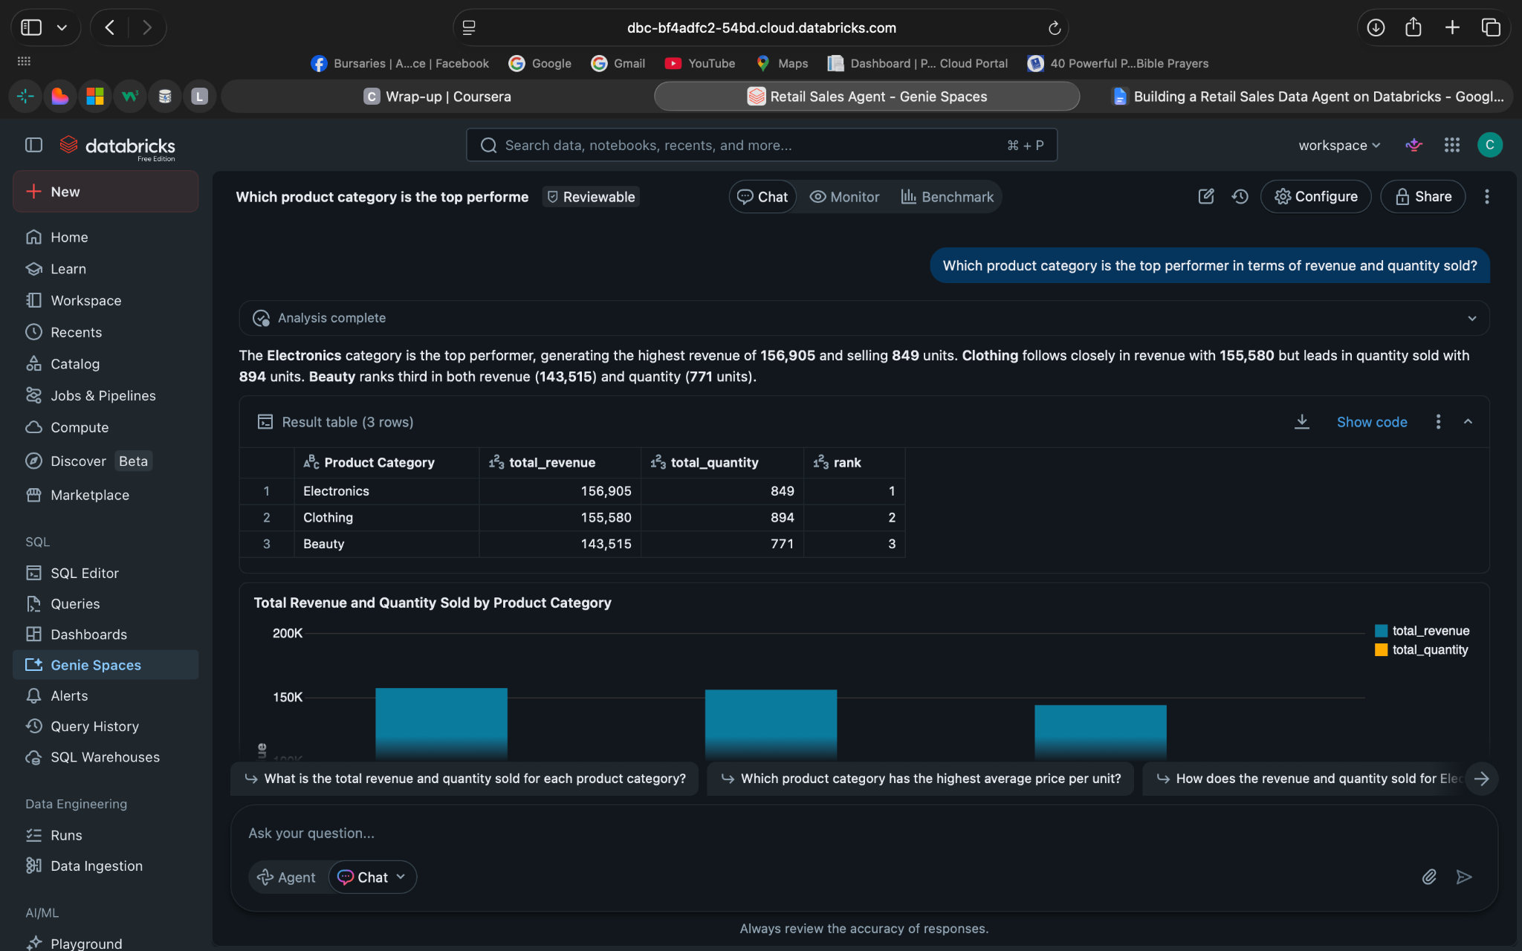

Q6 :Best-Performing Category
Which product category contributes the least revenue, and how significant is the gap compared to the top category?
Answer: Beauty
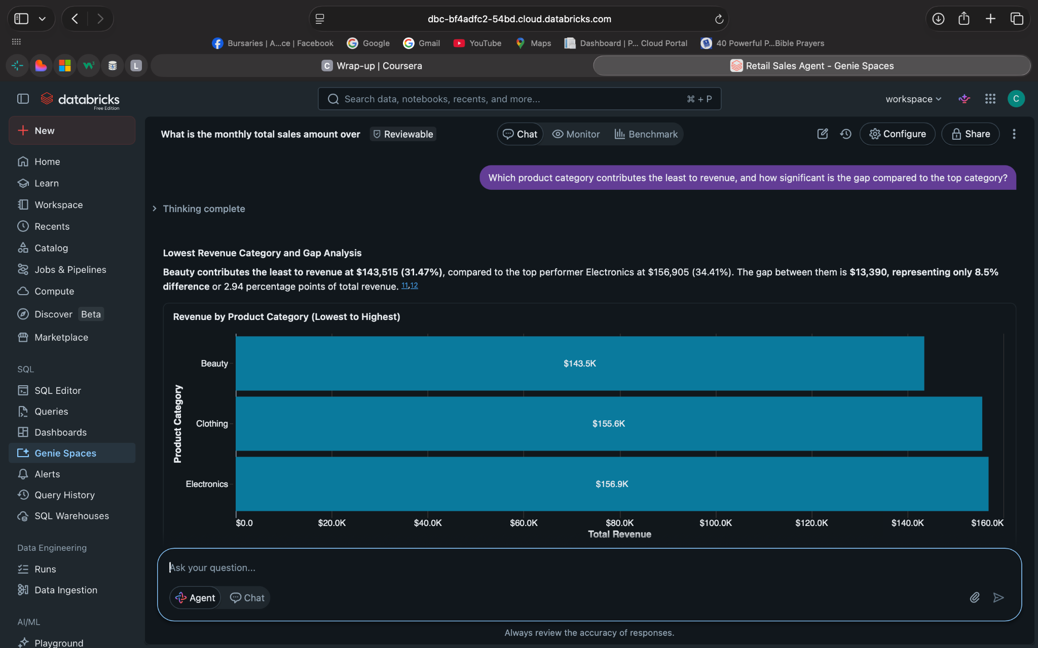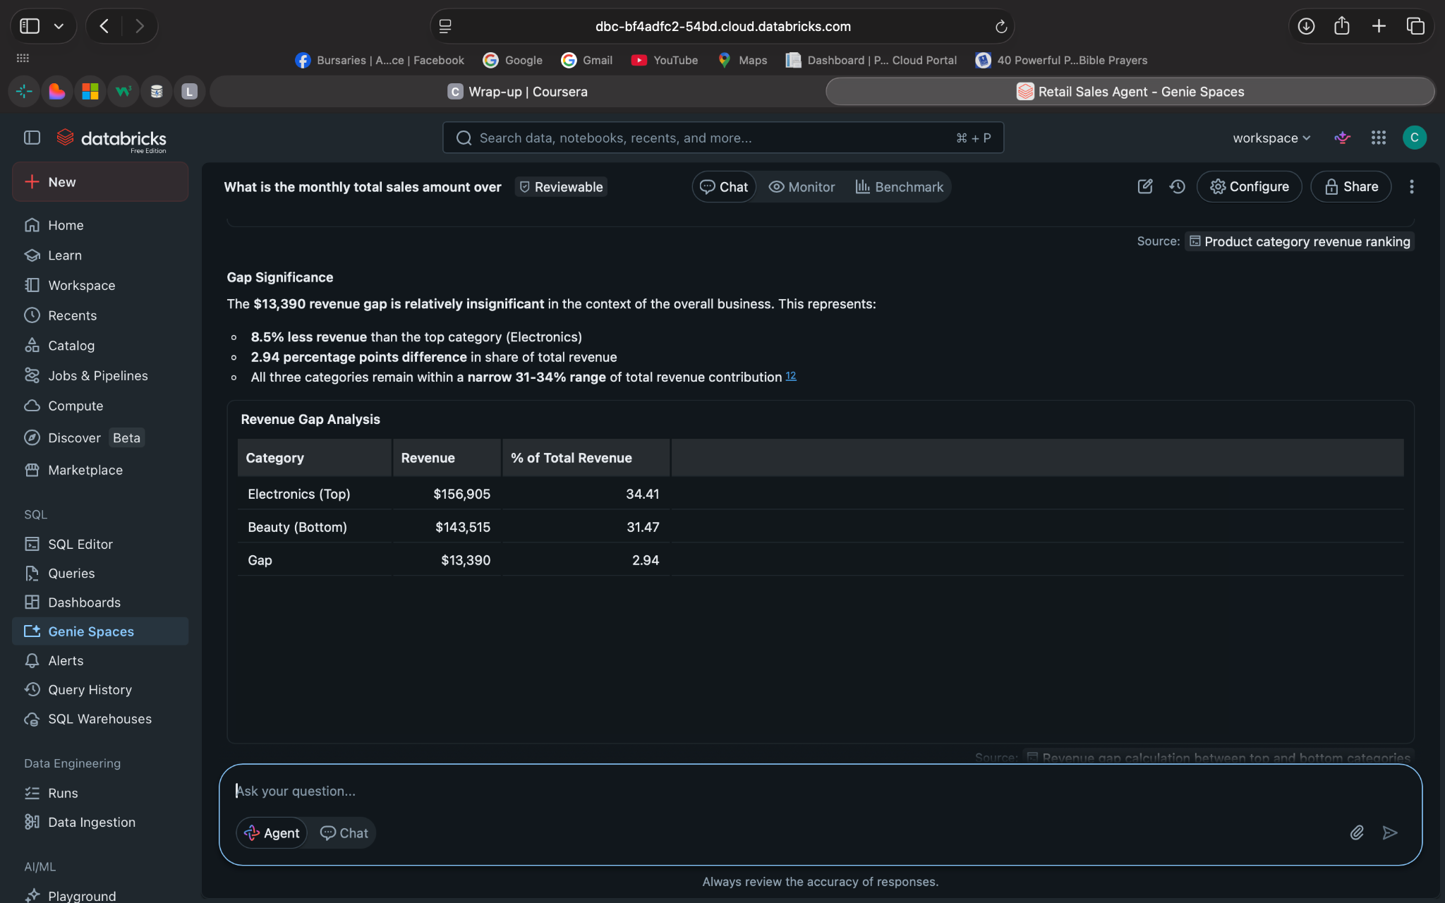

Q7 : Monthly Sales Trends
How have total sales changed over time on a monthly basis?
Answer: $37 873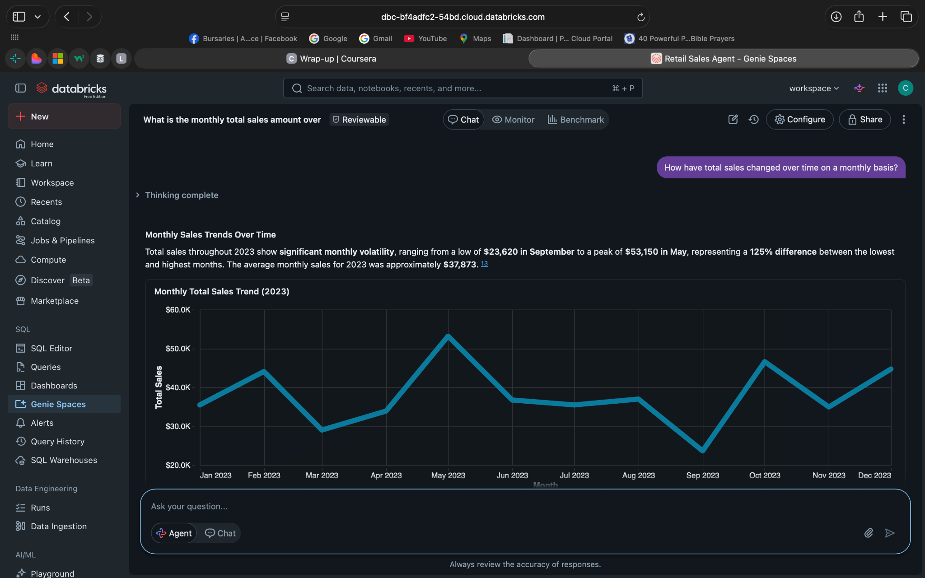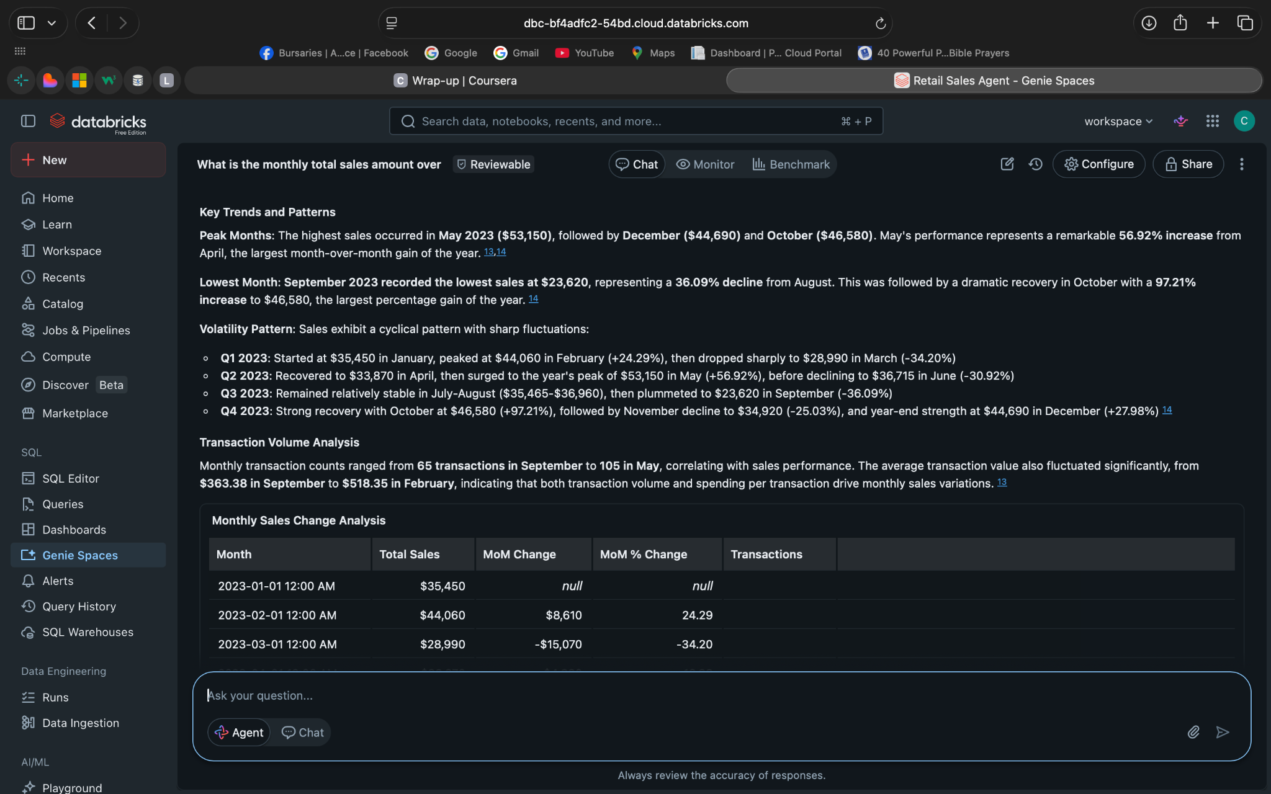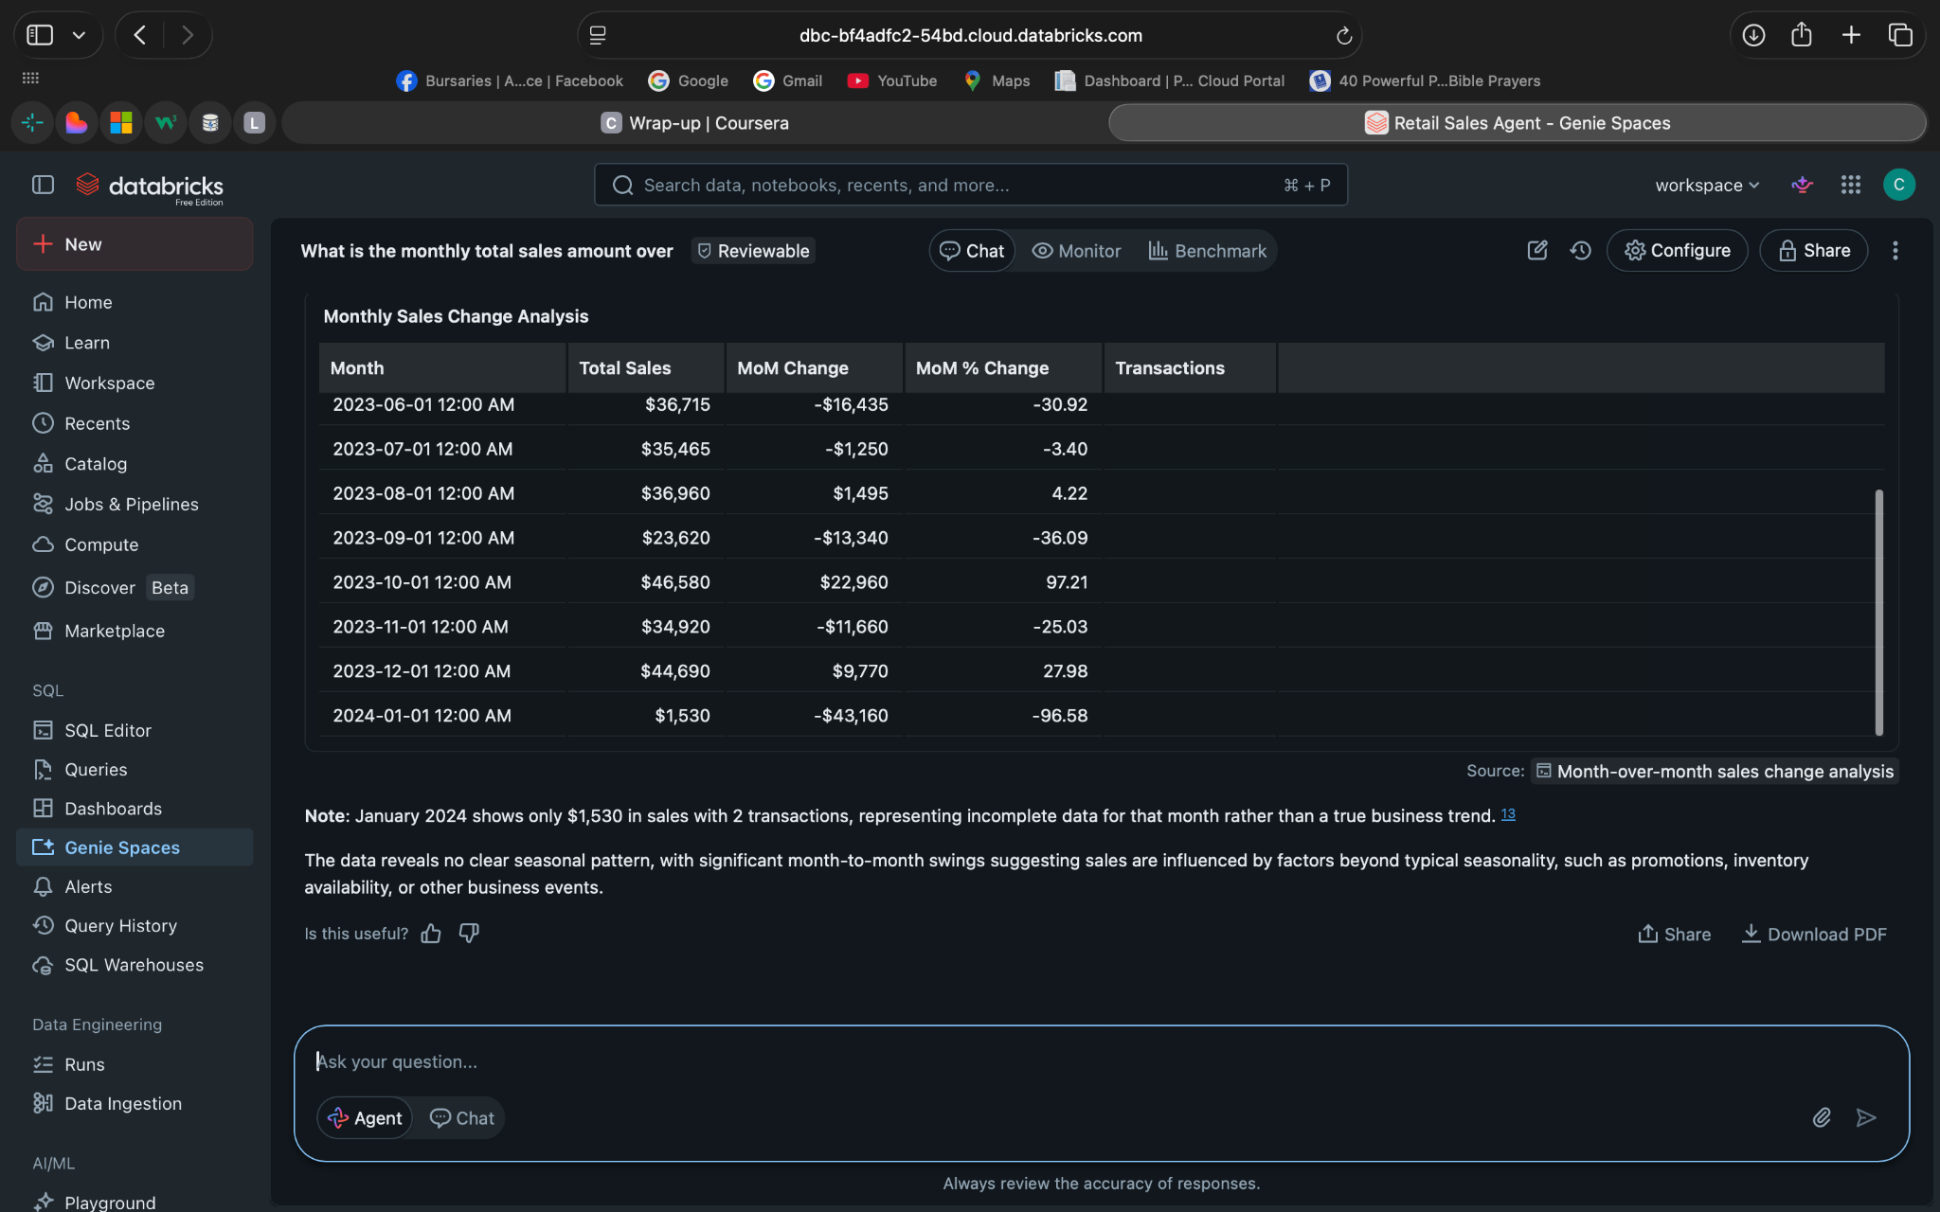
Q8 : Average Transaction Value
What is the average value of a single transaction?
Answer: $ 456 000
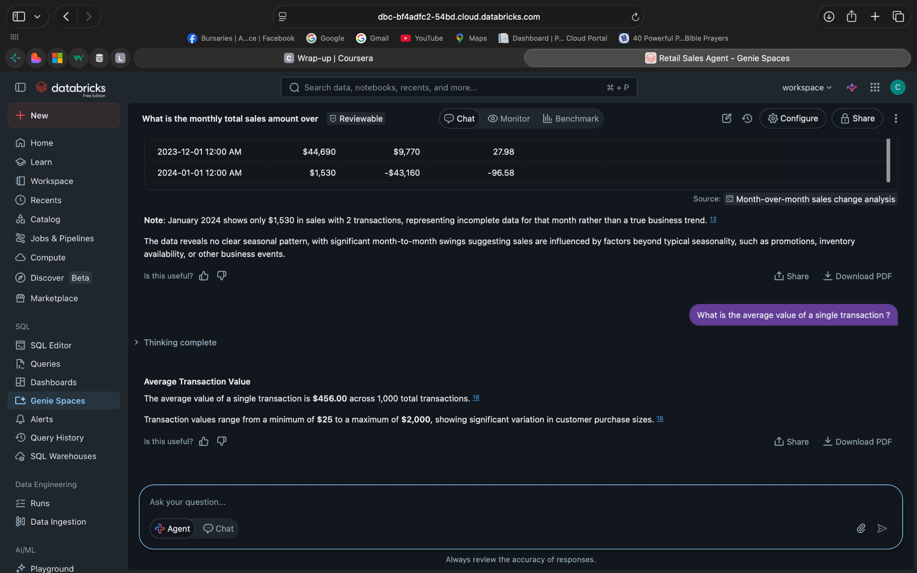
Q9: Customer Buying Behaviour
What patterns can be observed in customer purchasing behavior, such as or frequency of transactions?
Answer: 100% customers making only one transaction at a time

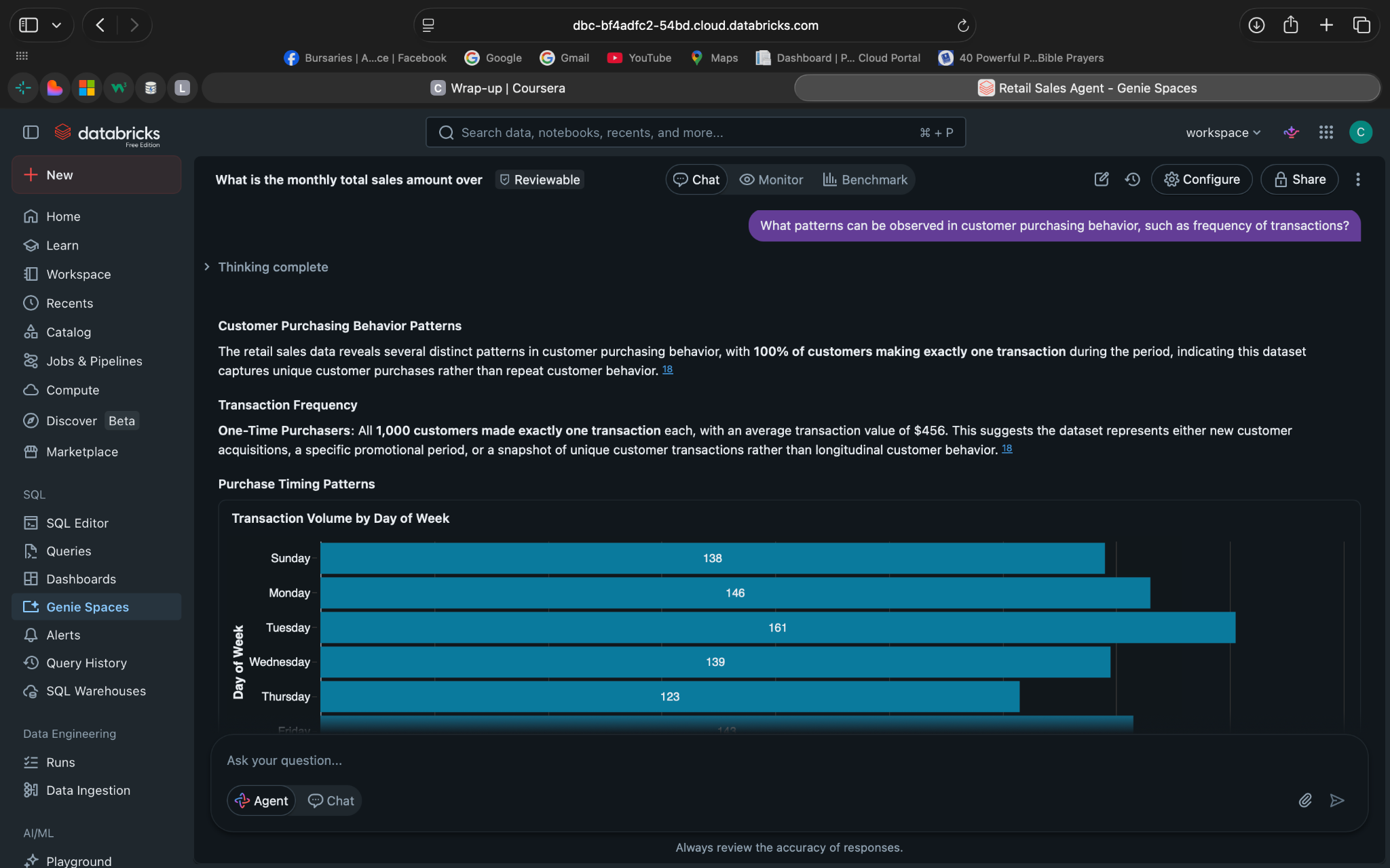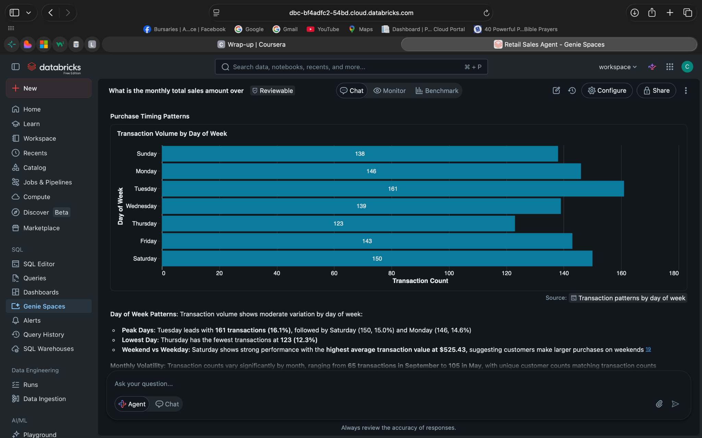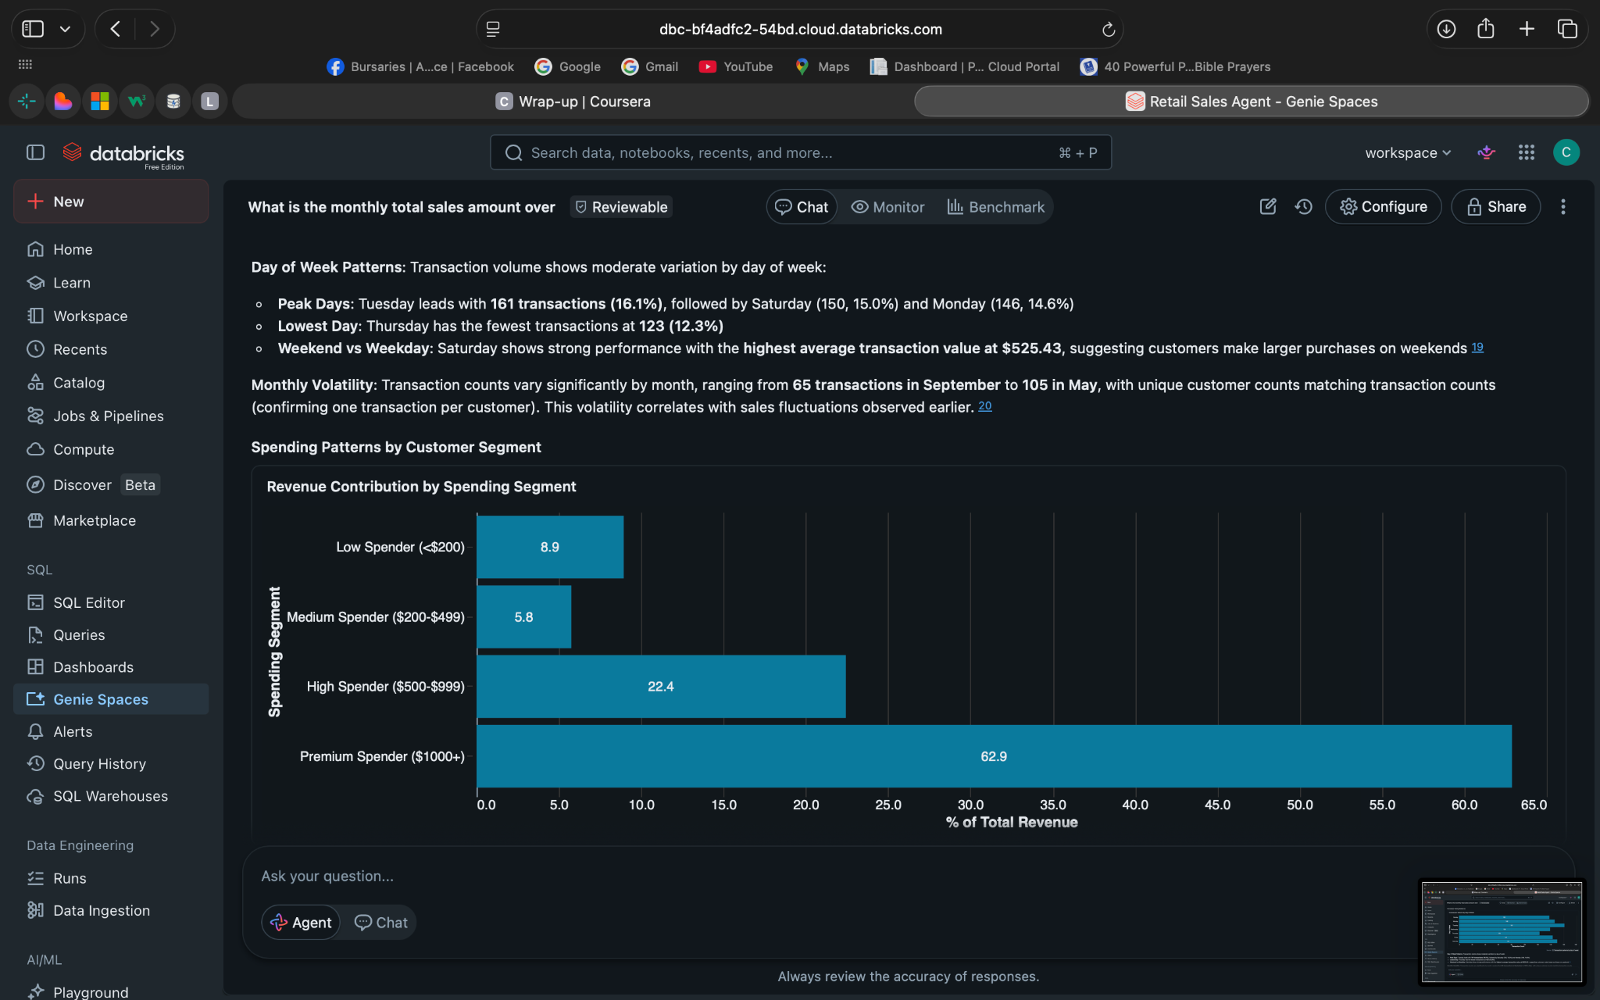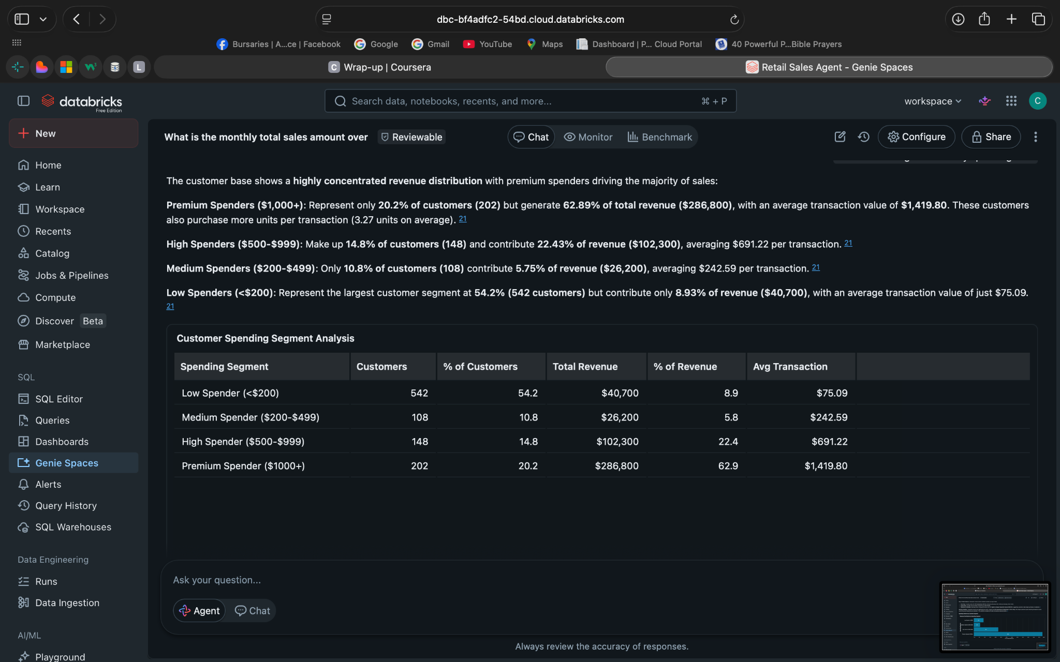
Q - 10 Business Recommendations
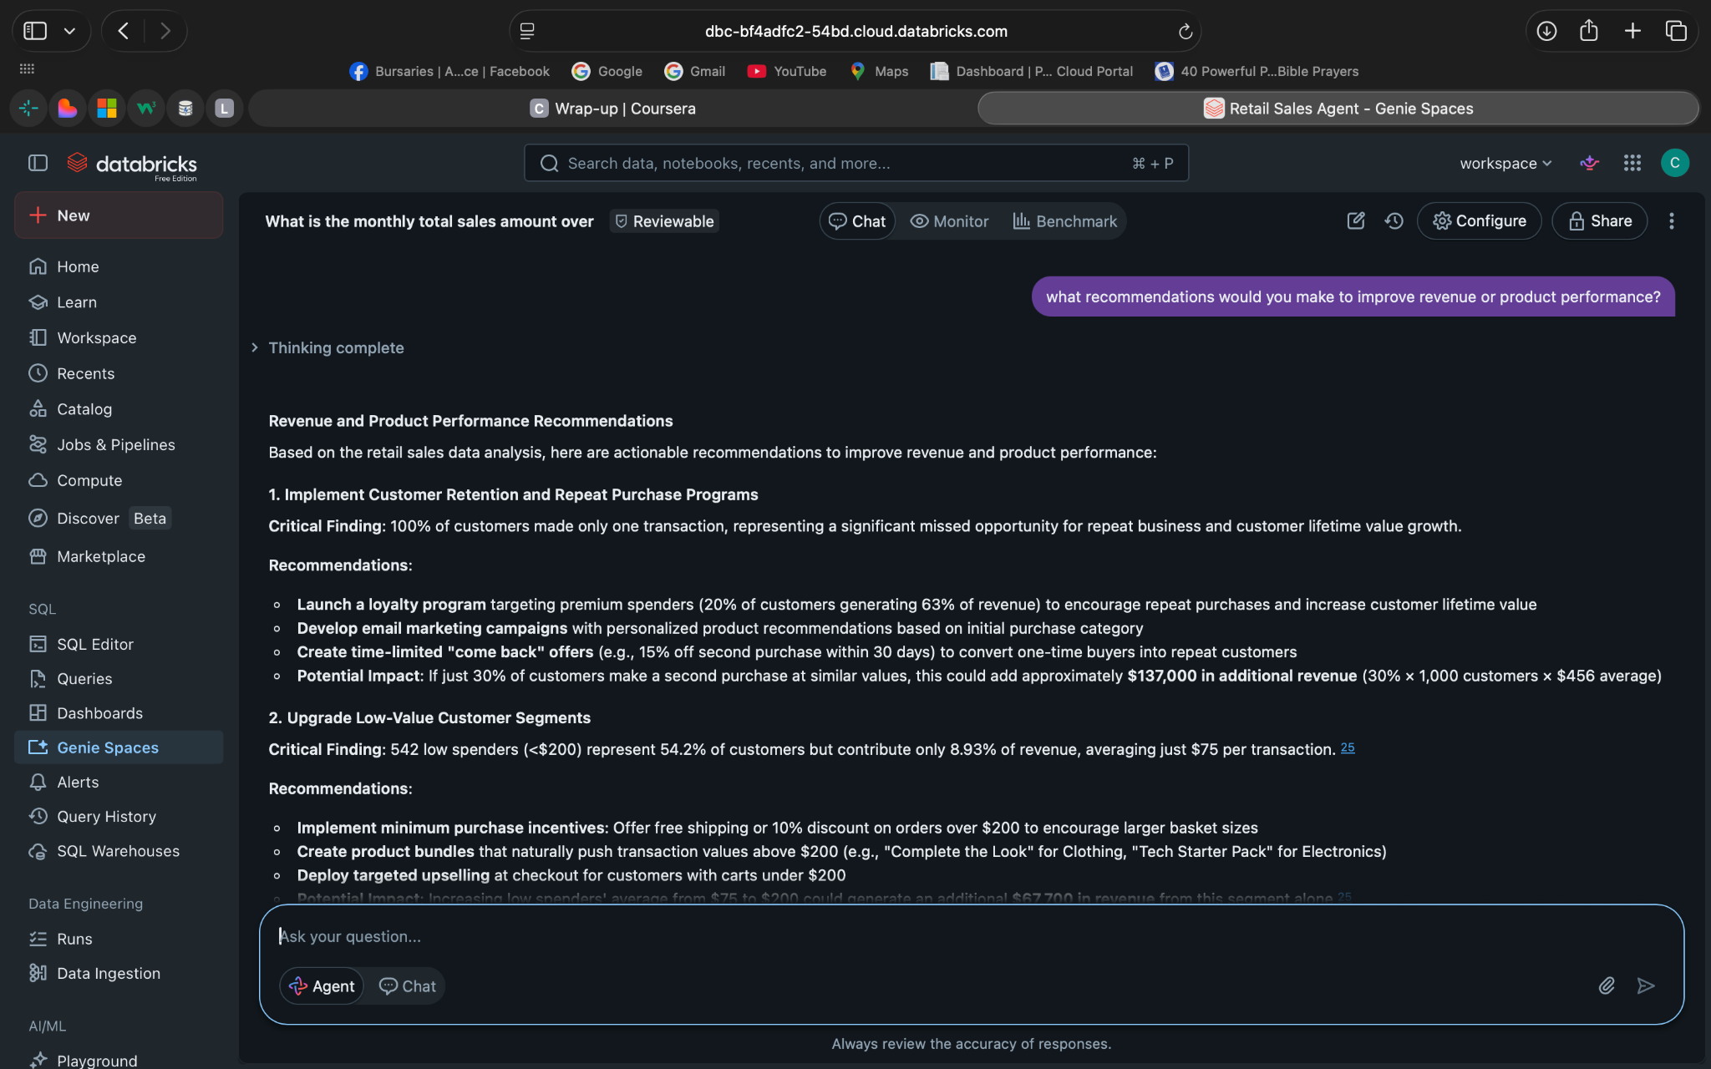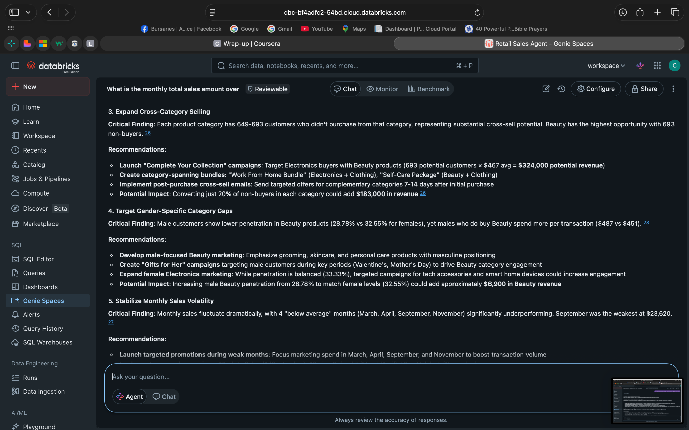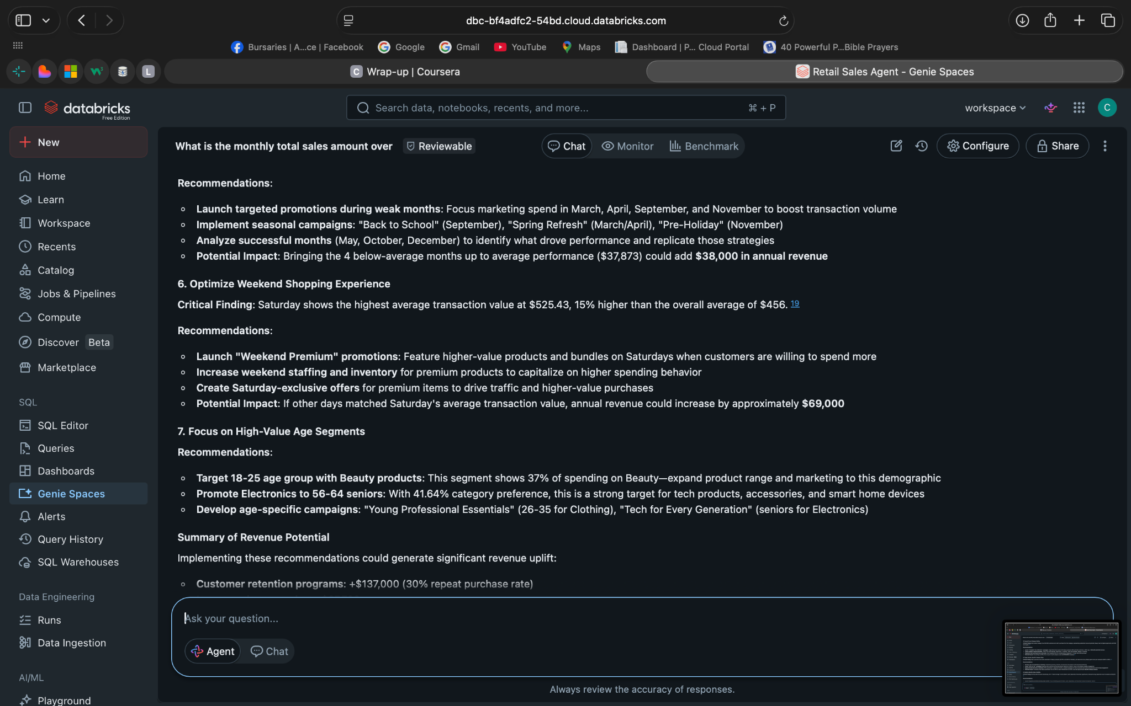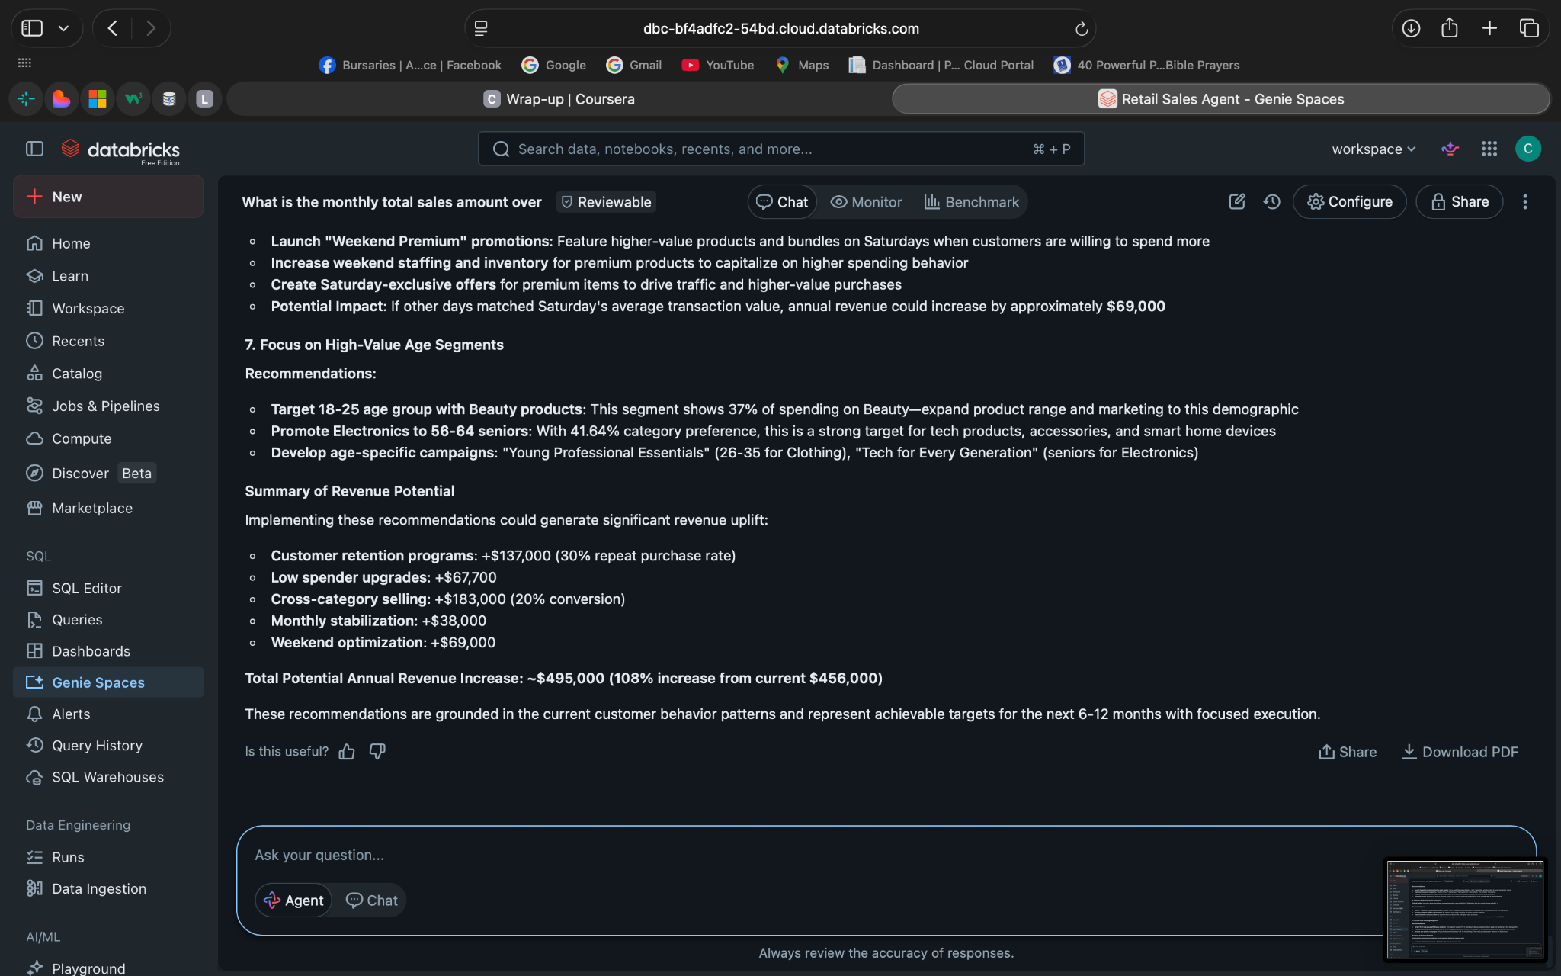

6. Validate 3 Answers
1. The agent's original question: What is the total revenue generated from the retail_sales_data dataset?

The supporting evidence you used to check it : SQL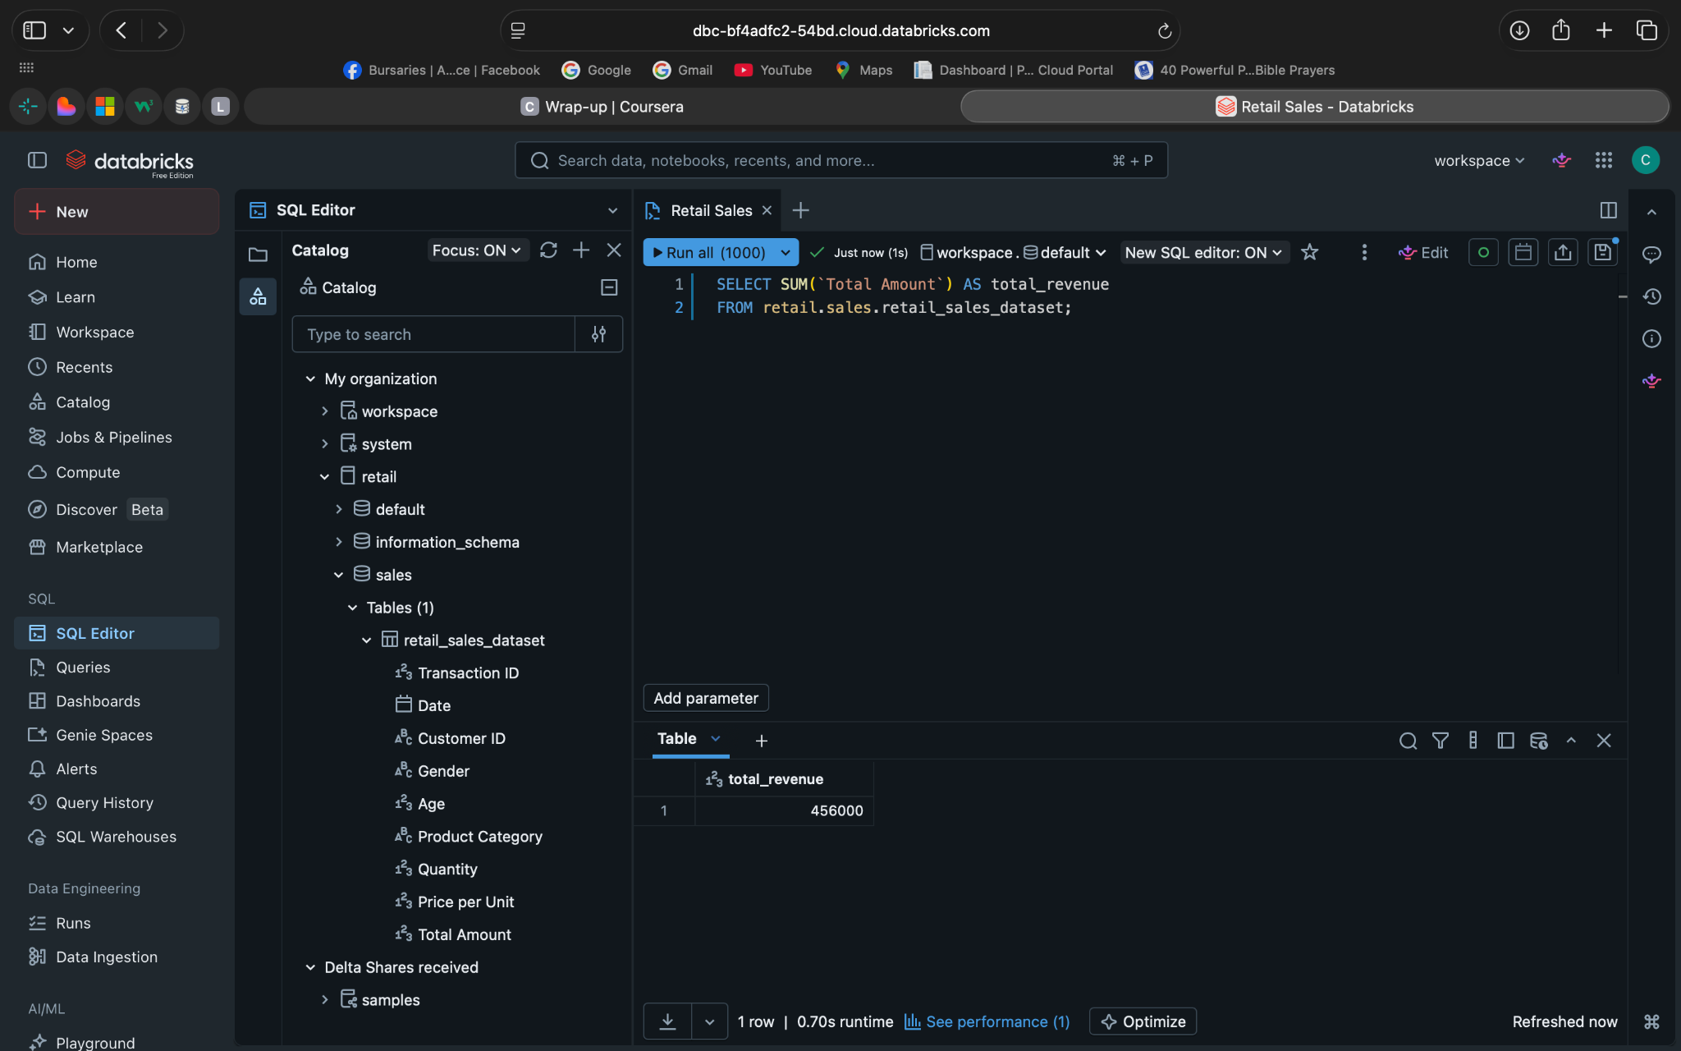
Final explanation : Correct answer

2. The agent's original question: Which product categories generate the highest total sales, and how do they compare?

The supporting evidence you used to check it : SQL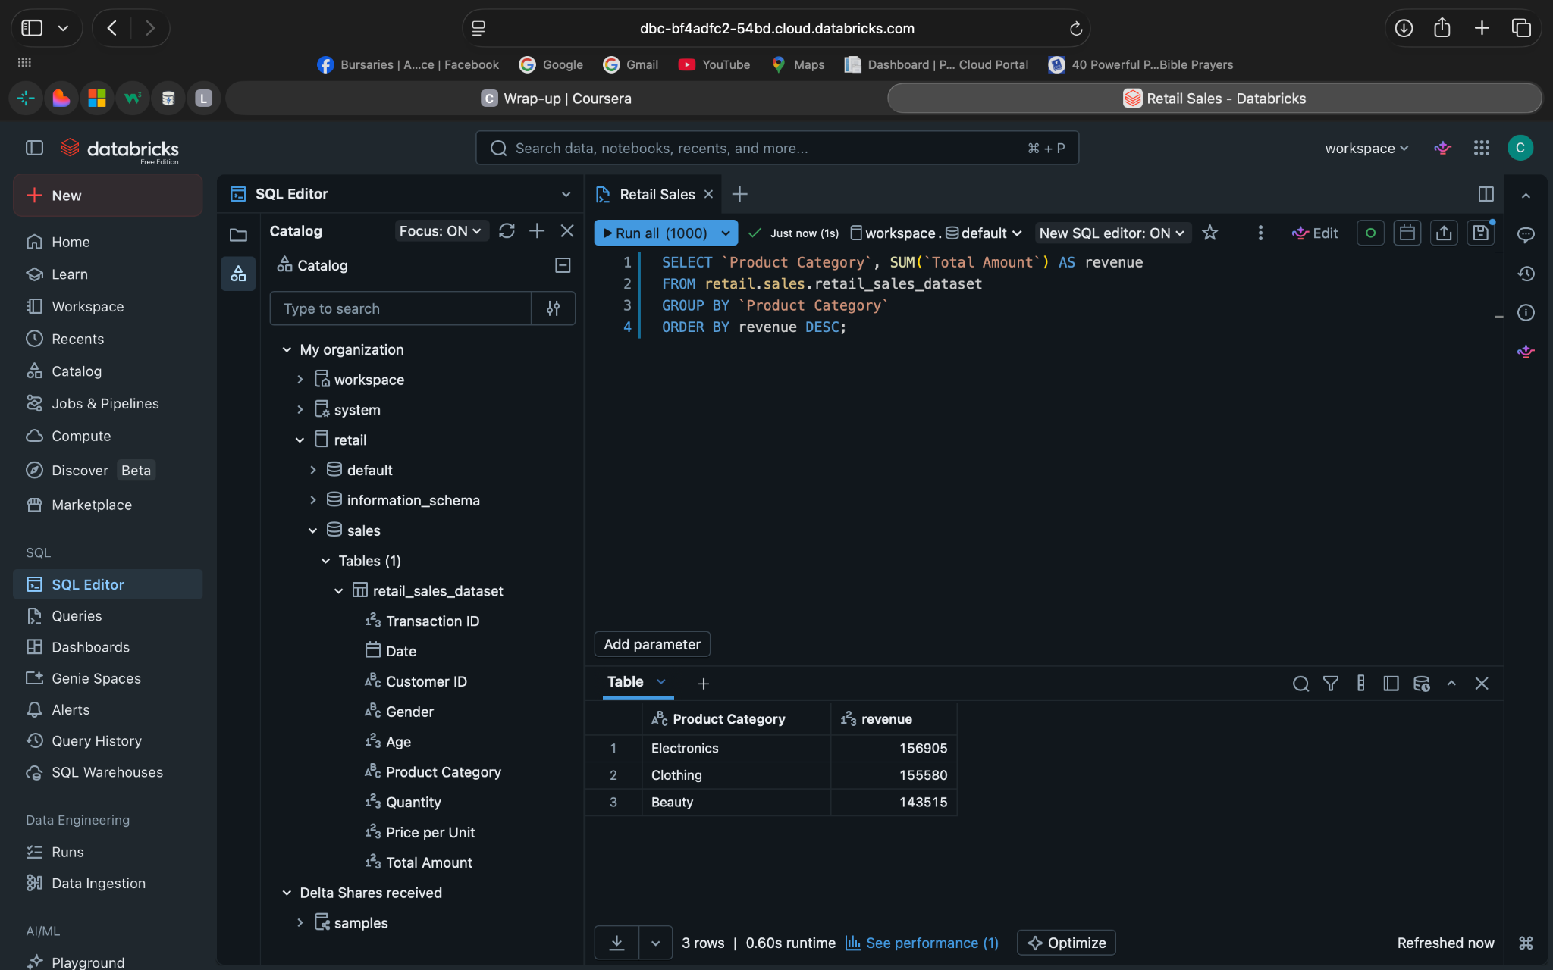

Final explanation: Correct

3. The agent's original question: Which age groups contribute the most to total sales?

The supporting evidence you used to check it : SQL
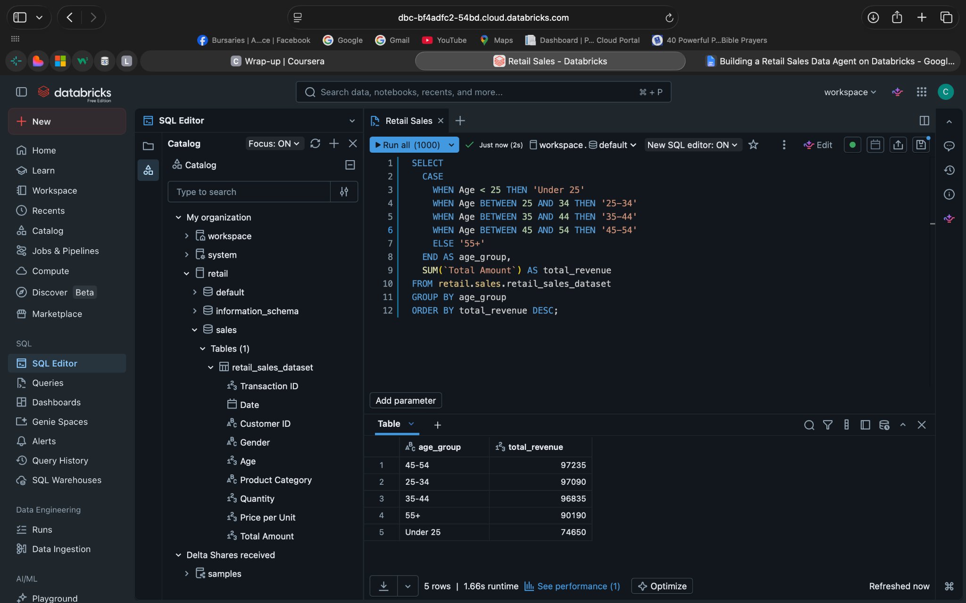
Final Explanation: Correct

7. Key insights
Key insights from the dataset included:
- Certain age groups contributed significantly more to total revenue
- A small number of product categories drove most sales
- Sales showed variation across months, indicating seasonal trends
- Average transaction value provided insight into customer spending behavior

8. Business recommendations
Based on the analysis from the retail sales agent, the business should focus more on the areas that are already performing well while improving weaker areas.
The products and categories that generate the most sales should receive more attention through stock availability, promotions, and marketing because they appear to drive most of the revenue. Lower-performing categories should be reviewed to understand whether the issue is pricing, customer demand, or product selection.
During high-sales periods, the business can prepare more inventory and staffing, while quieter periods could be used for promotional campaigns.
Customer information such as age groups and buying patterns can be used to target marketing more effectively and create offers that better match customer preferences.

9. Conclusion
The Databricks retail sales agent successfully provides structured, data-driven insights from transactional data. However, validation is essential to ensure accuracy and prevent incorrect assumptions.
By combining AI-generated responses with SQL-based verification, reliable and trustworthy business insights can be achieved.

10.Gitub Repository Link
https://github.com/CTurya/retail-sales-data-agent-databricks

